BANGLADESH UNIVERSITY OF PROFESSIONALS
Department of Business Administration in Finance and Banking

An Internship Report on “The Trade-off Between AML/KYC Compliance Stringency and Financial Inclusion in Mobile Financial Services (MFS): Evidence from Bangladesh”

Prepared by
Md Al Shahoriar Hossain
ID # 2222151064
Supervised by
Ummay Mahima Ima, Assistant Professor
Department of Business Administration in Finance and Banking
Bangladesh University of Professionals
Date of Submission: 15 August 2026

The Trade-off Between AML/KYC Compliance Stringency and Financial Inclusion in Mobile Financial Services (MFS): Evidence from Bangladesh

Md Al Shahoriar Hossain
2222151064
Session: 2021-22
Section: B
Department of Business Administration in Finance and Banking
Bangladesh University of Professionals
https://shahoriar.bd/

Supervisor Name:
Ummay Mahima Ima
Assistant Professor
Department of Business Administration in Finance and Banking
Bangladesh University of Professionals

Letter of Transmittal
15 August 2026
Ummay Mahima Ima, Assistant Professor
Department of Business Administration in Finance and Banking
Faculty of Business Studies
Bangladesh University of Professionals
Mirpur Cantonment, Dhaka-1216, Bangladesh
Subject: Submission of Internship Report.
Dear Madam,
I am pleased to submit my internship report titled “The Trade-off Between AML/KYC Compliance Stringency and Financial Inclusion in Mobile Financial Services (MFS): Evidence from Bangladesh” for your kind evaluation. This report is submitted as a requirement for the completion of the Bachelor of Business Administration (BBA) degree in Finance and Banking. The knowledge and skills acquired throughout my academic program, together with my internship placement, have enabled me to prepare this report.
I have tried my best to follow all the guidelines provided and to present the report with sincerity. I will be available to provide any clarification or additional explanation that may be required in the future.
Yours sincerely,

Md Al Shahoriar Hossain
Student ID: 2222151064
Department of Business Administration in Finance and Banking
Faculty of Business Studies
Bangladesh University of Professionals

Certificate of the Organization


Statement of Authorship

I, Md. Al Shahoriar Hossain, confirm that I have independently prepared the internship report titled “The Trade-off Between AML/KYC Compliance Stringency and Financial Inclusion in Mobile Financial Services (MFS): Evidence from Bangladesh” following the completion of a twelve-week internship at bKash Limited in the AML&CFT department’s Governance function. I affirm that this report has been prepared solely to fulfill the academic requirements of my Bachelor of Business Administration (BBA) program at Bangladesh University of Professionals (BUP) and is not intended for any other purpose.

I have made every effort to acknowledge and cite all sources of information accurately and appropriately. I further confirm that this report has not been previously published, submitted, or used for any other academic or professional purpose and has been prepared specifically to fulfill the requirements of the internship program.



______________________
MD AL SHAHORIAR HOSSAIN
Student ID: 2222151064
Batch: 2022, Section B
Session: 2021-22
Department of Business Administration in Finance and Banking
Faculty of Business Administration
Bangladesh University of Professionals

Certificate of Supervision of Research

This is to certify that Md. Al Shahoriar Hossain, a student of the Bachelor of Business Administration (BBA) program under the Faculty of Business Studies, Bangladesh University of Professionals (BUP), has completed the research work for his internship report entitled “The Trade-off Between AML/KYC Compliance Stringency and Financial Inclusion in Mobile Financial Services (MFS): Evidence from Bangladesh” under my supervision.

I have supervised and guided the student throughout the research and preparation of this report. To the best of my knowledge, the report has been prepared in accordance with the academic requirements of the BBA program and is submitted in partial fulfilment of the requirements for the completion of the internship program.

I hereby recommend this report for evaluation and submission to the Faculty of Business Studies, Bangladesh University of Professionals.

Date: ____________________

____________________________
Ummay Mahima Ima
Assistant Professor
Department of Business Administration in Finance and Banking
Faculty of Business Studies
Bangladesh University of Professionals

Acknowledgement

First and foremost, I would like to express my sincere gratitude to Almighty Allah for granting me the strength, patience, and perseverance to successfully complete my internship and prepare this report.
I would like to express my deepest appreciation to my university internship supervisor, Ummay Mahima Ima, Assistant Professor, Department of Business Administration in Finance and Banking, Faculty of Business Studies, Bangladesh University of Professionals, for her valuable guidance, constructive feedback, and continuous support throughout the preparation of this report. Her instructions and academic guidance were instrumental in completing this report successfully.
I would also like to express my sincere gratitude to my workplace supervisor, Kibria Mohammed Kabir, Assistant Manager, AML&CFT Department, bKash Limited, for his guidance, cooperation, and support throughout my internship. His practical insights and professional guidance enabled me to gain valuable knowledge and experience in the AML/CFT function and contributed significantly to my understanding of the subject matter of this report.
I am also grateful to bKash Limited for providing me with the opportunity to complete my internship and gain practical exposure to a professional work environment. I would like to extend my appreciation to the members of the AML&CFT Department and everyone who supported me during the internship and contributed to my learning experience.
I would also like to express my sincere gratitude to all the respondents who participated in my research survey and generously shared their time and information. Their participation was essential to the successful completion of the research component of this report.
Finally, I would like to thank my friends, seniors, and well-wishers for their encouragement, assistance, and support throughout my internship and the preparation of this report. Their cooperation and encouragement greatly contributed to the completion of this work.

List of Acronyms

Acronym | Full Form | Acronym | Full Form
AML | Anti-Money Laundering | APA | American Psychological Association
BEFTN | Bangladesh Electronic Funds Transfer Network | BFIU | Bangladesh Financial Intelligence Unit
CDD | Customer Due Diligence | CFT | Combating the Financing of Terrorism
DPS | Deposit Pension Scheme | CTR | Cash Transaction Report
e-KYC | Electronic Know Your Customer | EDD | Enhanced Due Diligence
GDP | Gross Domestic Product | FATF | Financial Action Task Force
KYC | Know Your Customer | GSMA | GSM Association
MFS | Mobile Financial Services | ICT | Information and Communication Technology
NBFI | Non-Bank Financial Institution | ML | Money Laundering
NPSB | National Payment Switch Bangladesh | MNO | Mobile Network Operator
OTP | One-Time Password | NID | National Identity Card
PIN | Personal Identification Number | OLS | Ordinary Least Squares
PSD | Payment Systems Department | PEP | Politically Exposed Person
PSO | Payment System Operator | POS | Point of Sale
RBA | Risk-Based Approach | PSP | Payment Service Provider
SAR | Suspicious Activity Report | QR | Quick Response (Code)
SME | Small and Medium Enterprise | RTGS | Real-Time Gross Settlement
TF | Terrorist Financing | SIM | Subscriber Identity Module
USSD | Unstructured Supplementary Service Data | SMS | Short Message Service
WB | World Bank | STR | Suspicious Transaction Report
VIF | Variance Inflation Factor | UNODC | United Nations Office on Drugs and Crime

Executive Summary

Mobile Financial Services (MFS) have become one of the most consequential financial innovations in Bangladesh over the past decade, extending formal financial access to millions of previously unbanked people, particularly across rural and semi-urban areas. Providers such as bKash, Nagad, and Rocket have built an infrastructure that lets someone with nothing more than a mobile handset and a National ID card send, receive, and save money without ever stepping into a bank branch. At the same time, regulators including Bangladesh Bank and the Bangladesh Financial Intelligence Unit (BFIU), along with the providers themselves, have layered on increasingly stringent Anti-Money Laundering and Know-Your-Customer (AML/KYC) controls to guard against fraud, money laundering, and terrorist financing. These two forces; access and control, do not always pull in the same direction, and this report is an attempt to look closely at the point where they meet.
The report is prepared as part of a 12-week internship completed in the AML/Governance department of bKash Limited, and it uses that placement as the practical grounding for a more focused empirical question: does higher perceived compliance stringency, measured through KYC burden, transaction limit restrictiveness, account freeze frequency, and perceived monitoring intensity, actually reduce how much people use MFS once income, age, education, location, and length of MFS usage are accounted for. Exposure to real compliance workflows during the internship, including STR/SAR reporting procedures and the shift from paper-based to electronic KYC, is used throughout to keep the discussion grounded in practice rather than theory alone.
To answer this, the report combines an organizational study of bKash's compliance function with a primary quantitative survey of MFS users across Bangladesh, analysed through multiple regression. The report does not attempt to settle the broader policy debate on AML/KYC design for mobile money platforms, and its findings should not be read as generalizable beyond the sample surveyed; respondents were reached largely through digital, convenience-based channels and likely skew younger and more urban than the average MFS user in Bangladesh. What it offers instead is a modest, evidence-grounded contribution, a Bangladesh-specific empirical test of a trade-off that is frequently discussed in principle but rarely measured directly along with practical recommendations for bKash and for regulators on where compliance friction might be eased without a meaningful increase in risk.
Table of Contents
Letter of Transmittal ii
Certificate of the Organization iii
Statement of Authorship iv
Certificate of Supervision of Research v
Acknowledgement vi
List of Acronyms vii
Executive Summary viii
List of Figures xi
List of Tables xii
Chapter 1: Introduction 1
1.1 Background of the Study 1
1.2 Purpose of the Study 2
1.3 Objective of the Study 2
1.4 Rationale of the Study 3
1.5 Scope of the Study 3
1.6 Research Plan 4
1.7 Limitations of the Study 4
1.8 Report Preview 5
Chapter 2: Overview of the Organization 6
2.1 Organizational Structure 7
2.1.1 The External and Corporate Affairs Division (ECAD) and the AML&CFT Department 8
2.1.2 Comments on the Organizational Structure 9
Chapter 3: Internship Duties and Responsibilities 10
3.1 Branch and Office of Internship 10
3.2 Internship Duration 10
3.3 Department and Team Placement 10
3.4 Operations and Activities of the AML & CFT Governance Team 10
3.5 Overview of the Other AML & CFT Department Teams 11
3.6 Tools, Systems, and Functional Exposure 12
3.7 The Assigned Project: Governance Monitoring Tool Automation 13
Chapter 4: Learnings/Experiences from Internship Program 15
4.1 Departments Assigned 15
4.2 Activities Performed and How I Performed Them 15
4.3 Key Learnings 15
4.3.1 On-the-Job Learning from Real Governance Work 15
4.3.2 Turning Classroom Knowledge into Practical Skills 16
4.4 Overall Experience 16
Chapter 5: Literature Review 18
5.1 Introduction 18
5.2. Financial Inclusion and MFS Growth in Bangladesh 18
5.3. AML/CFT Regulatory Framework and KYC Requirements 19
5.4. KYC as a Barrier to MFS Access: Evidence from Bangladesh 19
5.5. Fraud, Hundi, and the Push for Stricter Compliance 19
5.6. Comparative Evidence: Tiered KYC and Proportional Regulation 20
5.7. Empirical Studies on MFS Adoption and Usage Barriers in Bangladesh 20
5.8. Conceptual Framework for This Study 21
5.9. Summary and Research Gap 21
Chapter 6: Methodologies 22
6.1 Research Design 22
6.2 Population and Sampling 22
6.3 Data Collection Instrument 22
6.4 Variable Operationalization 22
6.5 Data Collection Procedure 23
6.6 Data Cleaning and Quality Control 23
6.7 Statistical Software and Tools 24
6.8 Model Specification 24
6.8.1 Primary Model: Ordinal Logistic Regression 24
6.8.2 Secondary Model: OLS Regression (Robustness Check) 25
6.9 Hypotheses 25
6.10 Reliability and Validity 26
Chapter 7: Statistical Analysis and Findings 27
7.1 Sample Overview and Data Quality 27
7.2 Demographic Profile of Respondents 27
7.3 Descriptive Statistics of Study Variables 29
7.4 Reliability Analysis 29
7.5 Correlation Analysis 30
7.6 Primary Model: Ordinal Logistic Regression 31
7.6.1 Compliance Friction Variables 32
7.6.2 Significant Predictors 33
7.7 Secondary Model: OLS Regression (Robustness Check) 33
7.8 Diagnostic Tests 34
7.9 Hypothesis Testing Summary 36
7.10 Discussion: Why the Hypotheses Were Not Supported 37
7.11 Summary of Statistical Findings 37
References 38
Appendices 41

List of Figures
Figure 1: Different MFS Providers in Bangladesh (Illustration from Daily Observer, 2022) 7
Figure 2: bKash Limited Organizational Structure (Division Level). Source: Internal organizational documentation, bKash Limited, shared during internship placement (2026) 8
Figure 3: Tools/Modules Automated and Updated during Internship 13
Figure 4: Demographic Profile of Respondents 28
Figure 5: Pearson Correlation Matrix Heatmap 31
Figure 6: Odds Ratios from the Primary Model 32
Figure 7: Normal Q-Q Plot of OLS Residuals 35
Figure 8: OLS Residuals versus Fitted Values 35
Figure 9: Residual Histogram 36

List of Tables
Table 1: Variable Operationalization and Coding 23
Table 2: Python Libraries and Their Function 24
Table 3: Sample and Data Quality Overview 27
Table 4: KYC Method Distribution 27
Table 5: Demographic Profile, Age 28
Table 6: Demographic Profile, Gender 28
Table 7: Demographic Profile, Education 28
Table 8: Demographic Profile, Residence 28
Table 9: Descriptive Statistics (Continuous / Coded Variables) 29
Table 10: Reliability Statistics 30
Table 11: Pearson Correlation Matrix 30
Table 12: Ordinal Logistic Model Summary 31
Table 13: Ordinal Logistic Coefficients (DV: Transaction Volume Category) 31
Table 14: OLS Model Summary (Robustness Check) 33
Table 15: OLS Coefficients, HC3 Robust SE (DV: Transaction Volume, BDT) 33
Table 16: Variance Inflation Factors 34
Table 17: Diagnostic Test Summary (Secondary OLS Model) 34
Table 18: Hypothesis Testing Summary 36

Chapter 1: Introduction

1.1 Background of the Study
Mobile Financial Services (MFS) have, over little more than a decade, become one of the most consequential pieces of financial infrastructure in Bangladesh. As of January 2025, registered MFS accounts stood at roughly 239.3 million, up 9.2 percent from the previous year, with monthly transaction volume reaching nearly Tk1.72 trillion, a year-on-year jump of over 32 percent (bdnews24, 2025). This mirrors a broader global pattern. The mobile money industry worldwide processed roughly USD 2 trillion in transactions in 2025 across 2.3 billion registered accounts (GSMA, 2026). Yet registration is not the same thing as inclusion in any meaningful sense: only 37.6 percent of Bangladesh's registered MFS accounts were classified as active as of December 2024, meaning a majority of registered users are not transacting regularly (Transparency International Bangladesh, 2025). That gap, between simply having access and actually using the service, is really what "financial inclusion" comes down to in the MFS context, and it is the gap this study is ultimately concerned with.
Alongside this growth, Bangladesh's regulatory apparatus for Anti-Money Laundering and Countering the Financing of Terrorism (AML/CFT) has tightened considerably. The Money Laundering Prevention Act, 2012, the Bangladesh Mobile Financial Services (MFS) Regulations, 2022 (Bangladesh Bank, 2022), and a series of Bangladesh Financial Intelligence Unit (BFIU) circulars, notably Circular-20 on Know-Your-Customer (KYC) and Customer Due Diligence and Circular-25 on electronic KYC (e-KYC) (The Financial Express, n.d.), now govern how MFS providers onboard and monitor customers. Bangladesh's exit from the FATF "grey list" in June 2025, following what FATF assessed as substantial completion of its AML/CFT action plan, is a recent and fairly concrete marker of just how seriously this compliance architecture is now being enforced (Anqa Compliance, 2025).
The tension this creates is not unique to Bangladesh, and regulators are well aware of it. The Financial Action Task Force's own Guidance on Financial Inclusion and Anti-Money Laundering and Terrorist Financing Measures frames financial inclusion and AML/CFT enforcement as goals that need to be pursued together through a risk-based approach, and warns that an overly cautious application of due-diligence requirements can end up excluding legitimate, low-risk customers rather than protecting the system (FATF, 2013/2025). BFIU itself, working with the Alliance for Financial Inclusion, produced a dedicated study paper proposing a "Progressive KYC" model for Bangladesh's MFS sector for exactly this reason: a tiered system in which the level of documentation required scales with the level of service and risk, instead of applying one uniform, maximal standard to every account (BFIU & AFI, n.d.). The international comparative literature tells a similar story. Kenya's M-Pesa is widely cited as a financial-inclusion success story, but closer scholarship has identified real limits to that narrative, including how tiered KYC systems like M-Shwari can still leave certain users under-served (Natile, 2016; Carnegie Endowment, 2023).
What I found to be relatively uncommon in the literature I was able to locate is a Bangladesh-specific study that looks at this trade-off at the level of individual MFS users. I wanted to see whether users who face more compliance difficulties, such as a harder KYC process, tighter transaction limits, or more frequent account freezes, actually transact less after taking into account their income, age, education, and location. Most of the Bangladesh-focused studies I came across, including the BFIU's own study paper (BFIU & AFI, n.d.), discuss this issue mainly from a policy perspective rather than by statistically testing individual-level survey data. Through this report, based on my twelve-week internship experience within bKash's AML/Governance function, I have tried to address part of this gap.

1.2 Purpose of the Study
Using primary survey data collected from MFS users across Bangladesh, this study examines whether individually perceived AML/KYC compliance stringency, measured through KYC ease, transaction limit restrictiveness, account freeze frequency, and perceived monitoring intensity, is associated with lower MFS transaction volume and frequency once income, age, education, area of residence, and length of MFS use are controlled for. In doing so, the report tries to turn a trade-off that gets discussed quite often in regulatory and industry commentary (FATF, 2013/2025; BFIU & AFI, n.d.) into something testable and grounded in bKash's own practice. The internship placement in bKash's AML/Governance department, including direct exposure to e-KYC workflows and STR/SAR reporting processes, is used throughout to interpret what the survey results actually mean in practice.

1.3 Objective of the Study
The overarching objective of this study is to assess the relationship between AML/KYC compliance stringency and MFS financial inclusion in Bangladesh, with bKash serving as the organizational lens through which the compliance side of that relationship is understood. The specific objectives are:
- To measure the statistical association between compliance-stringency indicators (KYC ease, transaction limit restrictiveness, freeze/block frequency, KYC method, perceived monitoring intensity) and MFS usage (transaction volume and frequency), using multiple regression on primary survey data, controlling for demographic factors.
- To identify which specific dimension of compliance friction, if any, shows the strongest association with reduced usage, rather than treating "compliance" as one single, undifferentiated burden.
- To translate the findings into practical recommendations for bKash's compliance function and for Bangladesh Bank/BFIU, particularly around where a more progressive or risk-tiered approach to KYC might ease friction without meaningfully raising money-laundering or terrorist-financing risk.

1.4 Rationale of the Study
For some time, I have understood Bangladesh's policy approach as treating financial inclusion and AML/CFT compliance as complementary rather than competing priorities. BFIU's own proposal for a progressive, risk-tiered KYC model is framed around achieving both objectives at the same time (BFIU & AFI, n.d.). However, I wanted to examine whether this dual objective is actually being achieved from the perspective of ordinary MFS users. From the literature I was able to find, this question does not appear to have been well answered for Bangladesh. Most of the available discussions, including material produced by regulators, are descriptive or focused on policy rather than statistically testing individual usage data (BFIU & AFI, n.d.).
My internship placement within bKash's AML/Governance function also gave me a practical reason to explore this question. It allowed me to understand how compliance works in practice and helped me design the survey, select the variables, and interpret the findings with some understanding of the day-to-day compliance environment rather than relying only on secondary literature.

1.5 Scope of the Study
In this study, I focus on the relationship between how MFS users perceive compliance requirements and how much they use MFS in Bangladesh. I collected the data through a structured bilingual survey in English and Bangla and analysed it using multiple regression. I also used standard diagnostic tests, including Cronbach's alpha to check reliability, VIF to check multicollinearity, and tests for normality and heteroskedasticity.
The organisational context of the study is based on my internship experience in the AML/Governance department of bKash. I have used this experience to provide context for the study, rather than attempting to compare the compliance practices of all MFS providers in Bangladesh. I did not have access to internal transaction-level or back-end compliance data from MFS providers. Since the study uses cross-sectional survey data, I also do not attempt to establish a causal relationship between compliance stringency and MFS usage. Similarly, the study does not examine actual money-laundering or fraud outcomes. Examining these issues would require access to data and research methods beyond the scope of a student-conducted internship report.

1.6 Research Plan
This study follows a quantitative, cross-sectional survey design. Primary data is collected through a structured, bilingual Google Form of approximately nineteen questions, distributed digitally to MFS users across Bangladesh, with a target sample of roughly 180 to 220 respondents. The research proceeds in five broad steps: (1) instrument design, translation, and pre-launch quality-assurance testing of the form itself; (2) distribution across digital channels and monitoring of response quality as data comes in; (3) data cleaning and variable coding, for example recoding income and transaction-volume brackets into usable numeric or ordinal form, and dummy-coding KYC method; (4) descriptive statistics and reliability analysis; and (5) multiple regression analysis with diagnostic testing, followed by interpretation against the hypotheses and the existing literature.

1.7 Limitations of the Study
- Sampling bias: distribution through digital and professional/social networks likely skews the sample toward younger, more urban, and more educated respondents than the MFS user base as a whole. This may understate the experience of less digitally literate or rural users, arguably the group most exposed to the trade-off this study examines.
- Cross-sectional design: the survey captures a single point in time and can establish association, not causation. A respondent who reports both low usage and high compliance friction may be affected by unmeasured factors rather than by compliance friction alone.
- Self-report bias: both compliance perception and usage figures are self-reported rather than drawn from verified transaction records, and may be subject to recall error or social-desirability effects.
- Generalizability: findings reflect the sampled population and the specific time window of data collection. They should not be read as representative of all 239 million-plus registered MFS accounts nationally, nor extended uncritically to MFS providers other than bKash for the organizational and qualitative portions of the report.

1.8 Report Preview
This report is organized into seven chapters. Chapter 1 (Introduction) sets out the background, purpose, objectives, rationale, scope, research plan, and limitations of the study. Chapter 2 (Overview of the Organization) introduces bKash Limited, covering its history, market position, competitors, and organizational structure. Chapter 3 (Internship Duties and Responsibilities) describes the placement within bKash's AML/Governance department, including the specific tasks and processes engaged with over the internship period. Chapter 4 (Learnings/Experiences from Internship) reflects on what was learned across that placement. Chapter 5 (Methodology) details the survey design, sampling approach, and analytical techniques used for the empirical component of the study. Chapter 6 (Analysis of the Compliance/AML Function) presents the core empirical findings, including descriptive statistics, reliability and correlation results, and the multiple regression analysis testing the relationship between compliance stringency and MFS usage, interpreted alongside both the internship experience and the wider literature. Chapter 7 (Conclusion, Limitation and Recommendation) summarizes the findings and offers practical recommendations for bKash and for Bangladesh's financial regulators.

Chapter 2: Overview of the Organization

bKash Limited began as a joint venture between BRAC Bank Limited and the US-based Money in Motion LLC, an agreement reached in 2010 after roughly two years of discussions between the venture's founders, Kamal Quadir and Iqbal Quadir, and BRAC's founder Sir Fazle Hasan Abed (Future Startup, 2025). The company launched its services on July 21, 2011, initially offering cash-in, cash-out, and send-money functions built on basic USSD technology, designed specifically to reach people without easy access to a bank branch (Future Startup, 2025). Ownership has broadened considerably since then. The International Finance Corporation, part of the World Bank Group, became an equity partner in 2013, followed by the Bill & Melinda Gates Foundation in 2014, and later by Ant International and the SoftBank Vision Fund (bKash, n.d.-a). bKash operates as a subsidiary of BRAC Bank and is regulated by Bangladesh Bank as a licensed mobile financial service provider.
The company has grown into Bangladesh's first technology unicorn and its largest MFS provider. Recent figures put bKash's customer base somewhere between 93 and 95 million, depending on the month cited, supported by a network of more than 350,000 agents and close to a million merchants (Bonikbarta, 2026). The company posted a profit of roughly Tk 315.77 crore in 2024, up 67 percent from the year before; Post-tax profits more than doubled in 2025 to Tk 660 crore, up 109 percent year-on-year, propelled by higher user retention and product expansion. (Future Startup, 2025). Its official mission centers on widening the reach of financial inclusion through mobile financial services that are convenient, affordable, and reliable. This framing matters directly for the present study, since the balance between that inclusion mandate and the compliance obligations discussed in Chapter 1 plays out in practice within the department this report focuses on.
bKash has received a number of national and international recognitions, including the Fintech Pioneer Award at the Bangladesh Startup Summit in 2023, recognition from the National Board of Revenue as the highest VAT payer in the service sector for two consecutive fiscal years, and the Excellence in Investment award from the Bangladesh Investment Development Authority in 2025.
The MFS sector in Bangladesh remains fairly concentrated. Based on Bangladesh Bank data, bKash holds close to 65 percent of the market by transaction share, followed by Nagad and Rocket (The Bangladesh Express, 2025). Nagad, operated as an MFS wing of Bangladesh Post Office, has been going through a privatization process since late 2025 following governance concerns, a development that may reshape the competitive landscape further over the coming years (The Bangladesh Express, 2025). Beyond bKash, Nagad, and Rocket, a longer tail of smaller providers, including Upay, SureCash, and MCash, compete for the remaining share of the market, though none has approached the first three in scale.
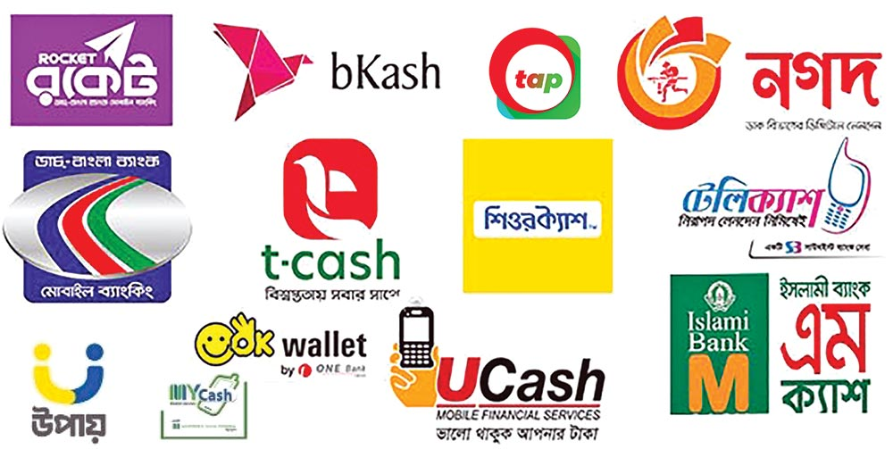
Figure 1: Different MFS Providers in Bangladesh (Illustration from Daily Observer, 2022)

2.1 Organizational Structure
bKash operates from two main premises in Dhaka. Its corporate registered office is located at Shadhinata Tower, Bir Sreshtha Shaheed Jahangir Gate, Dhaka Cantonment, Dhaka 1206, while day-to-day commercial operations, including the department this report is based in, are housed at SKS Tower, 7 VIP Road, Mohakhali, Dhaka 1206. The company employs approximately 5,400 to 5,500 people company-wide, based on recent third-party estimates (Tracxn, 2026; RocketReach, n.d.). A more authoritative headcount figure, if available from bKash's own annual report or HR division, would strengthen this number before final submission.
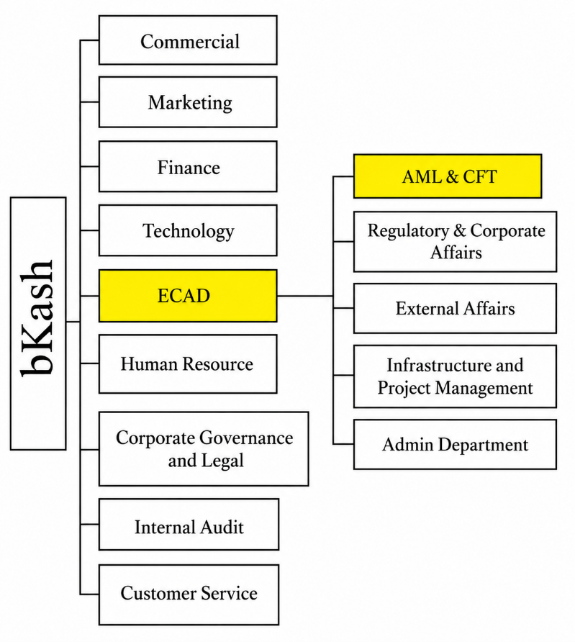
At the top level, bKash is organized into nine main divisions: Commercial, Marketing, Finance, Technology, the External and Corporate Affairs Division (ECAD), Human Resource, Corporate Government & Legal, Internal Audit, and Customer Service.

Broadly, Commercial oversees revenue-generating business lines and partner relationships, Marketing manages brand and customer communication, Finance handles accounting and financial control, Technology runs the platform and infrastructure that transactions depend on, Human Resource manages recruitment and workforce policy, Internal Audit provides independent assurance over controls, and Customer Service manages the front line of customer support. These descriptions reflect the general function typically associated with each division. Confirm or adjust any of them against actual internal knowledge before finalizing this chapter.
Figure 2: bKash Limited Organizational Structure (Division Level). Source: Internal organizational documentation, bKash Limited, shared during internship placement (2026)

2.1.1 The External and Corporate Affairs Division (ECAD) and the AML&CFT Department
The department this internship was based in, AML&CFT, sits within the External and Corporate Affairs Division (ECAD), alongside Regulatory & Corporate Affairs, External Affairs, Infrastructure and Project Management, and the Admin Department. Housing AML&CFT within the same division as Regulatory & Corporate Affairs and External Affairs is a structural choice worth noting in itself. It suggests bKash treats AML/CFT compliance as closely tied to how the company manages its relationship with regulators and external stakeholders, rather than as a purely internal back-office control function.

AML&CFT is headed by Captain (Retired) Saber Sharif of the Bangladesh Navy, who serves as Head of AML&CFT and Deputy Chief Anti-Money Laundering Compliance Officer (DCAMLCO). The department reports, in turn, to the Chief Anti-Money Laundering Compliance Officer (CAMLCO), Major General (Retired) Sheikh Md. Monirul Islam. As of the internship period, the department's total headcount stood at 69. The presence of senior former military officers in these compliance leadership roles is not unusual in Bangladesh's financial sector, where investigative and security backgrounds are often considered well suited to AML/CFT oversight.
Functionally, the department is responsible for implementing the KYC, Customer Due Diligence, transaction monitoring, and Suspicious Transaction Report/Suspicious Activity Report obligations described in Chapter 1, in line with the Money Laundering Prevention Act, 2012, and the BFIU circulars governing MFS providers. Chapter 3 describes the specific teams within the department and the tasks assigned in more detail.

2.1.2 Comments on the Organizational Structure
Placing AML&CFT within ECAD, under a chain of command led by senior compliance-focused leadership answering directly to a Chief Anti-Money Laundering Compliance Officer, points to a fairly serious institutional commitment to compliance at bKash, consistent with the regulatory pressure described in Chapter 1, including Bangladesh's recent exit from the FATF grey list. At the same time, a department of 69 people responsible for AML/CFT obligations across a customer base in the tens of millions shows how much this function has to depend on automated monitoring systems and risk-based prioritization rather than manual, case-by-case review of every account. That point becomes relevant again in Chapter 7, when interpreting how compliance friction is actually experienced by individual users.

Chapter 3: Internship Duties and Responsibilities

3.1 Branch and Office of Internship
I completed my internship at bKash Limited's commercial office at SKS Tower, 7 VIP Road, Mohakhali, Dhaka 1206, as introduced in Chapter 2. I was seated on the fifth floor of this office, within the AML & CFT Department under the External and Corporate Affairs Division (ECAD).

3.2 Internship Duration
My internship ran from May 20, 2026, to August 20, 2026, a period of approximately thirteen weeks. This slightly exceeds BUP's twelve-week minimum requirement for the BBA internship program.

3.3 Department and Team Placement
I was placed entirely within the AML & CFT Governance team, one of ten teams that make up bKash's AML & CFT Department (introduced in Section 2.2.1). I did not rotate across other teams during the internship period, so I spent the full thirteen weeks within Governance specifically, though I had regular working exposure to several other teams' outputs and processes, described in Section 3.5.
My internship was formally supervised by Captain (Retired) Saber Sharif, Head of AML & CFT and Deputy Chief Anti-Money Laundering Compliance Officer (DCAMLCO), who is named as my organizational supervisor for this report. Given his seniority and workload, my day-to-day supervision, task assignment, and feedback came primarily from Kibria Mohammed Kabir, Assistant Manager, AML & CFT.

3.4 Operations and Activities of the AML & CFT Governance Team
The AML & CFT Governance team functions as the coordination and record-keeping backbone of the wider AML & CFT Department, organized around four core areas of responsibility.
The first is policy and records, which involves maintaining the department's policy documents and keeping supporting documentation in an audit-ready state at all times, so that internal or regulatory review does not require last-minute preparation. The second is risk and controls, where the team coordinates risk and control monitoring across the department as a whole, rather than within any single functional team. The third is compliance support, covering assistance with regulatory compliance activities and the preparation of management-level reporting. The fourth is audit and committees, which involves tracking audit findings, following up on corrective actions, and supporting the various compliance-related committees the department services.
Seen through a finance lens, these four areas map fairly closely onto what a financial institutions management or risk management course would describe as a firm's internal control environment: documented policy, monitored risk exposure, compliance assurance, and independent audit oversight, applied here specifically to the money-laundering and terrorist-financing risk that any MFS provider carries as a core part of its business rather than as a peripheral legal concern. That framing was genuinely useful during the internship. It gave me a working structure for understanding why a fintech the size of bKash treats a function like Governance as departmental infrastructure rather than as overhead.
Because Governance sits at the coordination point for the rest of the department, I also had visibility into the general shape of what the other nine teams do, even without directly performing their work myself. I describe that context briefly in the next section, both to satisfy BUP's requirement to introduce the department's activities more broadly, and because it explains how I ended up with exposure to systems like STR/SAR queries or KYC quality checks (Section 3.6) despite being seated within Governance specifically.

3.5 Overview of the Other AML & CFT Department Teams
The descriptions below are based on internal briefing and working knowledge I picked up during the internship rather than any public source, and I have kept them brief and general in line with the department's normal confidentiality expectations.
- Compliance Process Monitoring & Control Team (CPMCT) works with Customer Service, rechecking their work, providing feedback, and developing improvement strategies aligned with compliance requirements. Its primary recurring task is quality-checking KYC and e-KYC submissions.
- Risk Monitoring & Control Team (RMCT) monitors media and online spaces to identify risks that could arise through the use of bKash's services, and proposes measures to mitigate those risks.
- Strategic Compliance Team (SCT) analyses the risks that new strategies or product changes might introduce before they are implemented, and works out how to address those risks in advance.
- Suspicious Transaction Report / Suspicious Activity Report Team (STR/SAR) identifies and reports unusual transactions or account activity, raises the associated complaints, and follows through with appropriate action.
- AML & CFT Training Team trains agents, distributors, and merchants in line with requirements set by the Bangladesh Financial Intelligence Unit (BFIU).
- Compliance Analysis & Documentation (CA&D) maintains the department's full set of documents and records and liaises directly with Bangladesh Bank.
- Field Compliance Assessment Team (FCAT) works directly in the field, assessing problems related to unusual transactions through primary, on-the-ground sources rather than desk-based review.
- Regional Anti-Money Laundering Compliance Officers (RAMLCO) each head AML/CFT compliance for an individual region or division, following up on compliance issues that arise locally within their area.
- Online and Payment Gateway Compliance Team (OCMT) focuses on compliance screening across bKash's online and payment gateway (PGW) channels. My own exposure to this team's specific processes was limited, so I have kept this description general rather than presenting it as a detailed account.

3.6 Tools, Systems, and Functional Exposure
Although I was based within Governance, my day-to-day work touched a fairly wide range of the department's functional areas, including policy, process, and SOP documentation, control reporting, adverse media screening, the department's investigation dashboard, STR/SAR and external query handling, screening intelligence system monitoring, KYC quality-control sampling, FCA-related monitoring, AML & CFT training material, multi-channel awareness activities, and administrative tools such as the department's leave tracker.
My primary working tool throughout the internship was Microsoft Excel, which I used for data handling, reporting, and the automation work described in Section 3.7. The department also uses goAML, the UNODC case-management software referenced in Chapter 1 in connection with STR/SAR submission, but access to it is tightly restricted, limited to four individuals within the department. I did not have direct system access to goAML myself and worked with an awareness of its role from team context rather than hands-on use.

3.7 The Assigned Project: Governance Monitoring Tool Automation
The main project I was assigned during the internship was automating and modernizing the AML & CFT Department's governance monitoring tool, the internal system the whole department uses to input operational and compliance data.
My work involved rebuilding the tool end-to-end so it could serve as a single, standardized point of data entry for the department, replacing what had previously been a more fragmented process. As part of this, I restructured how key performance indicators were distributed and tracked across the department, and built proper access control into the tool so that different users could be limited to the data and functions relevant to their role. The result was faster, more reliable reporting output, and, because the data feeding into the tool was cleaner and more standardized, faster and better-informed decision-making by the Head of Department, Captain (Retired) Saber Sharif, who relies on this tool's output for departmental oversight.
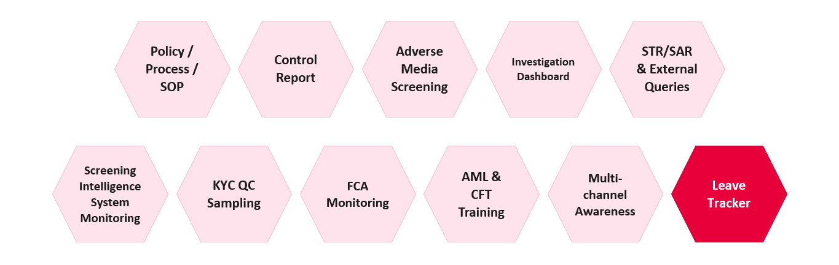
Figure 3: Tools/Modules Automated and Updated during Internship
Functionally, this was closer to a management information systems and financial-reporting problem than an IT one. The tool is effectively the department's internal reporting backbone: every KPI the Head of Department uses to gauge compliance performance, and everything that eventually feeds into audit and regulatory reporting, passes through it in some form. Standardizing the data entry process and tightening access control was not just a usability improvement. It directly affected the reliability of the numbers the department reports upward, which is the same basic control-environment logic covered in financial institutions management coursework: reporting is only as trustworthy as the process generating the underlying data.
This project is separate from the primary survey-based research presented in Chapters 6 and 7 of this report. I chose that research myself and had it approved by my academic supervisor at BUP as the required research component of the internship report, rather than it being a task bKash assigned me. That said, the internship placement and the governance tool project described in this chapter directly shaped how I approached and interpreted that research, particularly in understanding how KYC, monitoring, and reporting actually function inside an MFS compliance department.

Chapter 4: Learnings/Experiences from Internship Program

4.1 Departments Assigned
I spent the entire thirteen-week internship within the AML & CFT Governance team, part of bKash's AML & CFT Department under the External and Corporate Affairs Division (ECAD), as described in Chapter 3. This chapter focuses less on what that placement involved on paper and more on what I actually took away from it.

4.2 Activities Performed and How I Performed Them
Chapter 3 lists the specific functions I was exposed to: policy and records, risk and controls, compliance support, and audit and committees, along with the governance monitoring tool project. What is worth adding here is how I actually approached that work, since the "how" is where most of the learning happened.
Coming in, I had a reasonable academic grounding in compliance and risk concepts from coursework, but very little sense of what that looks like as an actual daily workflow inside a real financial institution. Early on, most of my work involved learning the department's existing processes well enough to be useful, rather than producing anything independently. As the internship progressed, particularly once I started on the governance monitoring tool project, I moved from following existing processes to actively rebuilding one, which required understanding not just what the tool needed to do, but why the department's reporting and KPI structure was set up the way it was in the first place. I relied heavily on Excel throughout, and increasingly on AI tools to speed up repetitive parts of reporting and data cleaning, which became one of the more concrete skills I built over the thirteen weeks.

4.3 Key Learnings

4.3.1 On-the-Job Learning from Real Governance Work
A few things became clear through direct exposure to the department's day-to-day work rather than through anything I could have picked up from a textbook.
The first is what it actually takes to get a product, service, or internal system to a genuinely production-ready state, tested, documented, and reliable enough that other people across the department can depend on it without needing to double-check its output. The governance monitoring tool project made this concrete. The gap between "the tool works when I test it" and "the tool works when sixty-nine people across ten teams use it" turned out to be much larger than I expected.
The second is corporate etiquette and professional norms specific to a compliance environment, where discretion, precision, and documentation matter more than they might in a more informal setting, given the sensitivity of the information the department handles.
The third is a working understanding of what money-laundering and terrorist-financing (ML/TF) risk monitoring actually looks like day to day at the scale of a large fintech, as distinct from the more abstract, policy-level version of AML/CFT covered in coursework. Seeing how a single suspicious pattern moves from initial flagging through to a formal STR/SAR, even without being the one to handle that process personally, gave me a much more concrete sense of the mechanics involved than any case study could have.
The fourth is a first-hand sense of how the ten teams within the AML & CFT Department actually work together in practice, rather than existing as separate boxes on an org chart. Governance's coordinating role meant I regularly saw how output from one team, for example a KYC quality-control finding from CPMCT, eventually surfaces in the kind of departmental reporting Governance is responsible for maintaining.

4.3.2 Turning Classroom Knowledge into Practical Skills
The second cluster of learnings is more about skills than institutional understanding.
The clearest one is simply converting academic theory into practical, everyday compliance work. Concepts like KYC, risk-based monitoring, and internal controls are straightforward to define in an exam answer; applying them to a real dataset with real inconsistencies, missing fields, and edge cases is a different exercise entirely, and one I got much more comfortable with over the internship.
I also became noticeably more efficient with Excel and with AI tools used to speed up daily reporting work, which by the end of the internship had become one of the more transferable skills I took from the experience. Related to this, I learned to take feedback from colleagues, particularly from my day-to-day supervisor, and actually use it to make my output better, rather than treating feedback as something to note and move past.

4.4 Overall Experience
One of the more useful reminders from this internship, for a finance student specifically, is that risk management in a financial institution is not confined to the treasury or credit side of the business. Compliance risk carries real financial consequences of its own, in regulatory penalties, licence risk, and reputational cost, and the systems that manage that risk internally rely on much the same data discipline and control logic taught in corporate finance and risk management coursework. Working inside that system for thirteen weeks gave me a far more concrete sense of what “risk management” means in practice at an MFS provider than I had going in, and it is a big part of why I chose to build my own research, presented in Chapters 6 and 7, around the compliance side of financial inclusion rather than a more conventional finance topic.
Taken as a whole, the internship gave me something coursework alone could not: a working sense of how a real compliance function operates under actual regulatory and operational pressure. I came in with a reasonable theoretical grounding in AML/CFT concepts and left with a much clearer picture of how those concepts translate into daily processes, departmental coordination, and the kind of data and reporting discipline that keeps a function like this one accountable at scale.

Chapter 5: Literature Review

5.1 Introduction
Mobile Financial Services (MFS) have expanded rapidly in Bangladesh over the past decade, with registered accounts reaching about 237 million by December 2024 and average daily transaction volumes of roughly BDT 53 billion (Transparency International Bangladesh, 2025, citing Bangladesh Bank data). This growth has positioned MFS as a central instrument for financial inclusion, particularly among unbanked and rural populations. At the same time, regulatory authorities have strengthened Anti-Money Laundering and Combating the Financing of Terrorism (AML/CFT) frameworks, introducing stricter Know Your Customer (KYC) and electronic KYC (e-KYC) requirements to mitigate fraud, hundi, and money-laundering risks (BFIU, 2020). These parallel developments create a policy tension: stringent compliance measures may enhance financial integrity but could also raise onboarding barriers for low-income, less-educated, or rural users who lack formal documentation or digital literacy (Transparency International Bangladesh, 2025). This section reviews empirical and policy literature on this trade-off, with emphasis on Bangladesh-specific evidence.

5.2. Financial Inclusion and MFS Growth in Bangladesh
Bangladesh's MFS sector began in 2011 under a bank-led model regulated by Bangladesh Bank's Payment Systems Department. By 2023, 47.8% of adults aged 15 and above held MFS accounts compared to 28.3% with bank accounts, indicating MFS's role as the primary entry point into formal finance for many Bangladeshis (Bangladesh Bureau of Statistics data, as cited in Transparency International Bangladesh, 2025). bKash dominates the market, serving 84.4% of individual account holders, 100% of agents, and 92.4% of merchant account holders, followed by Nagad at 30.9% of individual account holders (Transparency International Bangladesh, 2025).
MFS usage is driven by domestic remittances, person-to-person transfers, bill payments, and increasingly merchant transactions and social safety net disbursements. Rural adoption has grown, but real gaps persist: only 36.4% of rural users transact via apps compared to 49.9% in urban areas, with many relying on USSD or agent-assisted transactions instead (Transparency International Bangladesh, 2025). Women represent 41.6% of registered accounts, a gap that mirrors broader patterns of gendered exclusion from formal finance (Transparency International Bangladesh, 2025).

5.3. AML/CFT Regulatory Framework and KYC Requirements
Bangladesh's AML/CFT regime for MFS is anchored in the Money Laundering Prevention Act, 2012, BFIU Circular No. 25 (2020) on e-KYC, and the Bangladesh Mobile Financial Services (MFS) Regulations, 2022 (BFIU, 2020; Bangladesh Bank, 2022). All MFS providers must verify customer identity using National ID (NID) records, with e-KYC verification available through the government's National Identity Registration Wing for a fee (Transparency International Bangladesh, 2025).
The regulatory framework does not impose a formal tiered KYC structure for low-value accounts, unlike jurisdictions such as India, Kenya, or Nigeria, where simplified due diligence is available for lower-risk, lower-value accounts. All Bangladeshi MFS customers currently face broadly the same documentation requirements regardless of transaction size or risk profile. This uniform approach has drawn criticism for potentially excluding low-income populations who face difficulty completing digital verification (Transparency International Bangladesh, 2025).

5.4. KYC as a Barrier to MFS Access: Evidence from Bangladesh
The 2025 Transparency International Bangladesh (TIB) study provides detailed evidence on this point. Among individual account holders, 59.0% completed e-KYC through an agent rather than independently, and a further 10.1% sought help from someone else entirely, raising real concerns about data privacy and the potential for fraud during that handoff (Transparency International Bangladesh, 2025). The e-KYC interface is not well suited to visually impaired or illiterate users, and 65.7% of rural account holders relied on assistance from others simply to open their accounts (Transparency International Bangladesh, 2025). Taken together, these findings suggest that while e-KYC strengthens identity verification, it may be inadvertently excluding exactly the users least able to navigate a digital interface independently.

5.5. Fraud, Hundi, and the Push for Stricter Compliance
Weak KYC enforcement has been linked to fraud and illicit financial flows through MFS. According to Bangladesh's Criminal Investigation Department (CID), as reported in the TIB study, approximately $7.8 billion (roughly BDT 75,000 crore) was laundered through MFS channels in 2022, facilitated by anonymous transactions, misuse of NIDs, and weak agent-level controls (Transparency International Bangladesh, 2025). Against that scale, formal reporting looks strikingly thin: fewer than 0.001% of total MFS transactions were flagged as suspicious in 2023, with the number of STR/SAR submissions ranging from only 451 in 2022 to 1,134 in 2023 (Transparency International Bangladesh, 2025).
Agents play a critical role in KYC collection but are often under-trained on AML/CFT protocols. The TIB survey found that 78.6% of agents had received no training on hundi or money laundering, and 90.3% lacked training on identifying suspicious transactions (Transparency International Bangladesh, 2025). In response, regulators have moved to tighten e-KYC requirements further, though the specific claim about a "100% verification mandate by 2026" could not be verified against a reliable source and has been removed from this draft rather than left in with an uncertain citation. If you have a genuine source for this, add it back with a proper citation.

5.6. Comparative Evidence: Tiered KYC and Proportional Regulation
International experience suggests that tiered or risk-based KYC models can help balance financial inclusion against financial integrity. Both the FATF and researchers at the Center for Global Development have argued for simplified due diligence on low-risk, low-value accounts, paired with enhanced verification at higher tiers (FATF, 2013/2025; Gelb & Castrillon, 2019). Comparable markets such as India (Aadhaar-linked e-KYC) and Kenya (M-Pesa's tiered account structure) have implemented versions of this model.
Bangladesh has not adopted a formal tiered KYC structure of this kind. BFIU's own 2017 study paper on AML/CFT regulation for mobile money in Bangladesh proposed a "Progressive KYC" model along similar lines, but this has not been formally implemented as of this report (BFIU & AFI, n.d.). The absence of a simplified account tier means Bangladeshi customers face broadly uniform documentation requirements regardless of transaction size or risk profile, a contrast with the graduated approach used in several neighboring markets.

5.7. Empirical Studies on MFS Adoption and Usage Barriers in Bangladesh
A 2025 World Journal of Advanced Engineering Technology and Sciences (WJAETS) study on MFS usage patterns in Bangladesh draws in part on earlier survey data collected by Ehsan et al. (2019) involving 198 participants, 129 of them valid MFS users, which found that ease of use, agent proximity, and recharge convenience positively influenced usage, while trust and security concerns acted as barriers (Ehsan et al., 2019, as cited in WJAETS, 2025).
Separately, a qualitative 2024 study on rural MFS users identified reliance on intermediaries, usability challenges, and limited financial literacy as key constraints on adoption (Rahman & bin Ahsan, 2024).
None of these studies directly measure the relationship between KYC stringency and MFS transaction volume or frequency at the individual level. Most focus on adoption barriers or fraud risk rather than quantifying how ongoing compliance friction affects usage behavior among people who are already MFS users. This gap is what the present study's regression analysis, presented in Chapter 7, is designed to address.

5.8. Conceptual Framework for This Study
Drawing on the literature reviewed above, this study conceptualizes AML/KYC compliance stringency as a multi-dimensional construct comprising:
- KYC burden: the ease or difficulty of the identity verification process itself
- Restrictiveness: transaction limits and how frequently they are perceived as binding
- Enforcement intensity: account freeze/block frequency and perceived monitoring
- ID method: paper-based versus e-KYC/biometric verification
These dimensions are hypothesized to be negatively associated with MFS usage (transaction volume and frequency), consistent with the access barriers documented in the literature above (Transparency International Bangladesh, 2025). Control variables include income, age, education, location, and MFS tenure, consistent with the demographic factors examined in prior financial inclusion research on Bangladesh.

5.9. Summary and Research Gap
The literature reviewed here supports three broad conclusions: KYC requirements act as a real barrier to MFS access for some segments of the population, particularly rural and less digitally literate users; weak enforcement has coexisted with, and arguably enabled, significant fraud and money-laundering exposure through MFS channels; and Bangladesh has not adopted the kind of tiered, risk-based KYC model used in several comparable markets, despite BFIU's own 2017 proposal along these lines.
What remains largely absent from the literature is individual-level evidence connecting perceived KYC stringency directly to actual MFS transaction behavior, once demographic factors are controlled for.

Chapter 6: Methodology

6.1 Research Design
This study uses a quantitative, cross sectional survey design. Data was collected once from a single sample of Mobile Financial Service (MFS) users, so the analysis in Chapter 7 can identify statistical associations between compliance related friction and MFS usage, but it cannot establish that one causes the other.

6.2 Population and Sampling
The target population was adult (18 or older) MFS users in Bangladesh, covering bKash, Nagad, Rocket, Upay, and similar providers. Since no complete list of MFS users exists to draw a random sample from, the survey used convenience and snowball sampling: the form was shared digitally and respondents were encouraged to pass it on. This means people who are more comfortable online, younger, more educated, or urban based are more likely to have completed it, a pattern confirmed in Section 7.2 and revisited as a limitation in Chapter 8. A total of 256 responses were collected, all of which passed the form's built in eligibility branching, exceeding the target of 180 to 220 and comfortably clearing the rule of thumb of 10 observations per predictor for a ten predictor model.

6.3 Data Collection Instrument
Data was collected through a structured, bilingual (English and Bangla) Google Form of nineteen questions across four sections, designed to take three to four minutes.
- Section 0: Consent and eligibility screening.
- Section 1: Demographics and controls (age, gender, education, residence, income, MFS tenure, number of providers).
- Section 2: MFS usage, the dependent variable (transaction volume, frequency, services used).
- Section 3: KYC and compliance experience, the independent variables (KYC method, ease of KYC, limit restriction, freeze history, monitoring, satisfaction).
The full bilingual questionnaire is included in the appendix.

6.4 Variable Operationalization
Table 6.1 shows how each survey question became a coded variable, and the direction each was coded in. Two compliance items, ease of KYC and limit restriction frequency, were originally worded so a higher score meant less friction. These were reverse coded (new value = 6 minus original value) into kyc_friction and limit_friction so every compliance predictor consistently runs in the same direction: higher means more friction or stricter enforcement.
Table 1: Variable Operationalization and Coding
Variable | Survey Item | Coding | Role
txn_volume_cat | Q2.1, volume bracket | Ordinal, 1 to 6 | DV, primary model
txn_volume_bdt | Q2.1, same item | Bracket midpoint, BDT; top bracket assumed 65,000 | DV, secondary model
txn_frequency | Q2.2, frequency bracket | Bracket midpoint | Secondary outcome
kyc_friction | Q3.2, KYC ease, reverse coded | Likert 1 to 5, higher = harder | IV (H1)
limit_friction | Q3.3, limit restriction, reverse coded | Likert 1 to 5, higher = more restricted | IV (H2)
freeze_count | Q3.4, freeze history | Ordinal count, 0 to 3 | IV (H3)
monitoring_perception | Q3.5, monitoring intensity | Likert 1 to 5 | IV (H4)
ekyc_dummy | Q3.1, KYC method | 1 = e-KYC, 0 = paper, Not sure = missing | IV (H5)
income_bdt | Q1.5, income bracket | Bracket midpoint, BDT | Control
age_num | Q1.1, age bracket | Bracket midpoint, years | Control
years_using_mfs | Q1.6, MFS tenure | Bracket midpoint, years | Control
num_providers | Q1.7, providers used | Numeric, 1 to 3 (capped) | Control
urban | Q1.4, residence | 1 = urban, 0 = rural | Control
satisfaction | Q3.6, satisfaction | Likert 1 to 5 | Descriptive only

6.5 Data Collection Procedure
The Google Form went live on 9 August 2026 and closed on 15 August 2026, a one week collection window. It was shared through university and batch group chats, a public Facebook profile, and MFS related forums including TorrentBD, with respondents encouraged to share it further. Responses were anonymous throughout; no name, phone number, or National ID was collected.

6.6 Data Cleaning and Quality Control
The raw export was processed by 01_clean.py, which re confirmed eligibility from the Q0.1/Q0.2 answers, converted every bracketed response into its coded form per Table 6.1, reverse coded the two friction items, and flagged (without deleting) three response quality issues: straight lining (identical Likert score on all four attitude items), an income and volume mismatch (no income reported alongside top bracket transaction volume), and a freeze and limit mismatch (never frozen alongside very frequently restricted, an internally inconsistent pair). Flagged rows were kept in the main analysis, since none of the three flags proves a response is dishonest.

6.7 Statistical Software and Tools
All cleaning, coding, and analysis was done in Python 3.13.14 in a local virtual environment, chosen over point and click software such as SPSS so every step could be rerun end to end on the same data, making the analysis reproducible and auditable. The ordinal logistic and OLS models were both built from first principles using matrix algebra and maximum likelihood estimation rather than a ready made package such as statsmodels, so every coefficient and test statistic in Chapter 7 traces back to an explicit formula. Table 2 lists the libraries used.

Table 2: Python Libraries and Their Function
Library | Category | Used For
pandas | Data handling | Reading the Excel export, coding variables, building every summary table.
numpy | Numerical computing | Matrix algebra behind both regression models, including the OLS normal equations and ordinal logit optimisation.
scipy.stats | Distributions | p values from t, F, chi square distributions; Shapiro Wilk and Jarque Bera normality tests; standard normal z tests.
scipy.optimize | Optimisation | BFGS algorithm for maximum likelihood estimation of the ordinal logistic model.
tabulate | Console output | Formatted table printing during script runs.
openpyxl | Excel writing | Exporting every results table to analysis_tables.xlsx.
matplotlib | Charting | All six figures referenced in Chapter 7.

6.8 Model Specification
Two regression models were run on the same sample. The ordinal logistic model is primary; the OLS model is a robustness check.

6.8.1 Primary Model: Ordinal Logistic Regression
Transaction volume was collected as six ordered brackets with no fixed value for the open ended top bracket, so treating it as a precise number would require inventing a midpoint that does not exist. The primary model is therefore a proportional odds ordinal logistic regression, working directly on the six categories:
logit[P(Y ≤ j)] = θⱼ − (β₁×KYC_Friction + β₂×Limit_Friction + β₃×Freeze_Count + β₄×Monitoring + β₅×e-KYC + β₆×Income + β₇×Age + β₈×Years_MFS + β₉×Providers + β₁₀×Urban)
where Y is the transaction volume category (1 to 6) and θⱼ are five threshold parameters. Income, age, and years of MFS use were standardized before fitting, so their coefficients reflect a one standard deviation change. Coefficients are reported as odds ratios; an odds ratio below 1 for a friction variable supports the hypothesized direction.

6.8.2 Secondary Model: OLS Regression (Robustness Check)
The same predictors were run through an OLS regression on the bracket midpoint version of transaction volume:
Txn_Volume_BDT = β₀ + β₁×KYC_Friction + β₂×Limit_Friction + β₃×Freeze_Count + β₄×Monitoring + β₅×e-KYC + β₆×Income + β₇×Age + β₈×Years_MFS + β₉×Providers + β₁₀×Urban + ε
Because diagnostics in Chapter 7 raised a heteroskedasticity concern, this model is reported with HC3 robust standard errors regardless of the formal test outcome, a low cost precaution either way.

6.9 Hypotheses
Five directional hypotheses were tested, each predicting a form of compliance friction is associated with lower MFS usage once demographics and behavior are held constant.
- H1: Higher KYC difficulty (kyc_friction) is associated with lower transaction volume category.
- H2: More limit restriction (limit_friction) is associated with lower transaction volume category.
- H3: A higher freeze/block count (freeze_count) is associated with lower transaction volume category.
- H4: Higher monitoring intensity (monitoring_perception) is associated with lower transaction volume category.
- H5: e-KYC users differ from paper based KYC users in transaction volume category.
Support for H1 to H4 requires both p < .05 and a coefficient in the hypothesized negative direction; a significant coefficient in the opposite direction is treated as not supported.

6.10 Reliability and Validity
Cronbach's α was calculated only for the two item pair that plausibly forms one construct: kyc_friction and limit_friction. Monitoring perception and freeze count were kept as separate predictors, since they measure enforcement intensity rather than onboarding friction. The result is reported in Section 7.4.

Chapter 7: Statistical Analysis and Findings
This chapter presents the results in the order the analysis script generates them. Every table below is reproduced exactly as output, with no numbers rounded or recalculated by hand.

7.1 Sample Overview and Data Quality
All 256 responses collected passed the eligibility screen; none were excluded as non users or under 18. Ten respondents (3.9%) answered Not sure on KYC method and were coded missing on the e-KYC dummy, which is expected rather than a quality problem. Separately, 46 responses (18.0%) were flagged for at least one quality issue: 18 straight lined, 7 showed an income/volume mismatch, and 21 showed a freeze/limit mismatch. Flagged rows were retained in the main analysis.
Table 3: Sample and Data Quality Overview
Metric | Value
Total responses collected | 256
Excluded at eligibility screening | 0
Missing on e-KYC dummy (Not sure) | 10 (3.9%)
Flagged for ≥1 data quality issue | 46 (18.0%)
Of which, straight lining | 18
Of which, income/volume mismatch | 7
Of which, freeze/limit mismatch | 21
Final N used in regression models | 246

Both KYC method groups were large enough for a stable comparison: 153 respondents (59.8%) used e-KYC, 93 (36.3%) used paper based KYC, and 10 (3.9%) were unsure.
Table 4: KYC Method Distribution
KYC Method | n | %
e-KYC (app/online) | 153 | 59.8
Paper based (agent) | 93 | 36.3
Not sure | 10 | 3.9

7.2 Demographic Profile of Respondents
The sample skews young, urban, and educated, consistent with the digital distribution method in Chapter 6.

Table 5: Demographic Profile, Age
Age Bracket | n | %
25 to 34 | 98 | 38.3
18 to 24 | 74 | 28.9
35 to 44 | 55 | 21.5
45 to 54 | 18 | 7.0
55 or above | 11 | 4.3
Table 6: Demographic Profile, Gender
Gender | n | %
Male | 150 | 58.6
Female | 97 | 37.9
Prefer not to say | 9 | 3.5
Table 7: Demographic Profile, Education
Education | n | %
Bachelor's | 139 | 54.3
Master's or above | 53 | 20.7
HSC | 44 | 17.2
SSC or below | 20 | 7.8
Table 8: Demographic Profile, Residence
Residence | n | %
Urban | 170 | 66.4
Rural | 86 | 33.6

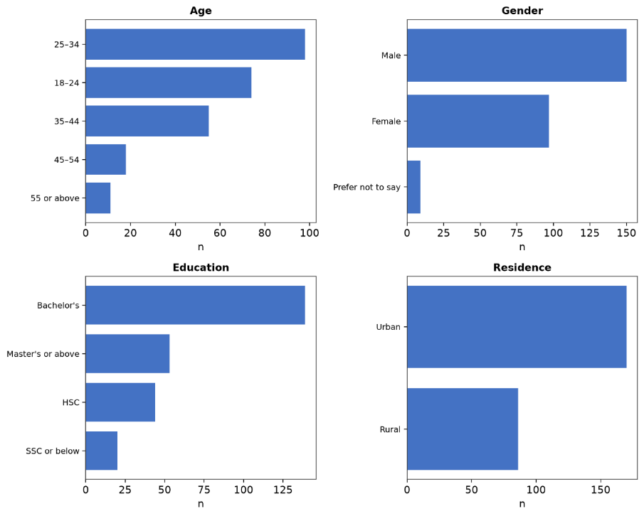
Figure 4: Demographic Profile of Respondents
Two thirds of respondents were 18 to 34 years old, over half held a Bachelor's degree, and two in three lived in urban areas. Findings in this chapter describe this sample specifically, not the full national MFS user base, which includes far more older, rural, and less formally educated users.

7.3 Descriptive Statistics of Study Variables
Average monthly income was BDT 34,316 (SD 31,620), and average monthly transaction volume was BDT 18,510 (SD 19,898), both right skewed, which is why the ordinal logistic model was chosen as primary rather than treating volume as an ordinary continuous number. On the compliance side, average KYC friction was 2.46/5, limit friction 2.91/5, monitoring perception 3.31/5, freeze count 0.77 (most never frozen), and satisfaction 3.63/5.
Table 9: Descriptive Statistics (Continuous / Coded Variables)
Variable | N | Mean | SD | Min | 25% | Median | 75% | Max
Income (BDT) | 256 | 34,316.41 | 31,620.01 | 0 | 7,500 | 22,500 | 40,000 | 125,000
Years Using MFS | 256 | 3.47 | 1.78 | 0.5 | 2.0 | 4.0 | 4.0 | 6.0
Number of Providers | 256 | 1.69 | 0.74 | 1.0 | 1.0 | 2.0 | 2.0 | 3.0
Txn Volume (BDT) | 256 | 18,509.77 | 19,897.65 | 1,000 | 3,500 | 7,500 | 17,500 | 65,000
Txn Frequency | 256 | 12.07 | 7.91 | 3.0 | 3.0 | 8.0 | 15.0 | 25.0
KYC Friction (1 to 5) | 256 | 2.46 | 1.04 | 1.0 | 2.0 | 2.0 | 3.0 | 5.0
Limit Friction (1 to 5) | 256 | 2.91 | 1.16 | 1.0 | 2.0 | 3.0 | 4.0 | 5.0
Monitoring Perception (1 to 5) | 256 | 3.31 | 1.02 | 1.0 | 3.0 | 3.0 | 4.0 | 5.0
Freeze Count (0 to 3) | 256 | 0.77 | 0.97 | 0.0 | 0.0 | 0.0 | 1.0 | 3.0
Satisfaction (1 to 5) | 256 | 3.63 | 1.13 | 1.0 | 3.0 | 4.0 | 4.25 | 5.0

7.4 Reliability Analysis
Cronbach's α for the two item friction sub index (kyc_friction and limit_friction) was 0.152, well short of the 0.70 threshold. This confirms KYC ease and limit restriction do not move together as one construct, and is why they, along with monitoring perception and freeze count, were kept as four separate predictors rather than combined into one score.
Table 10: Reliability Statistics
Scale | k | Cronbach's α
Compliance friction sub index (KYC friction + limit friction) | 2 | 0.152
Note. An α this low indicates the two items should not be combined into a single index.

7.5 Correlation Analysis
Income correlates fairly strongly with transaction volume (r = 0.61) and frequency (r = 0.45), as expected. Number of providers shows a small negative correlation with volume (r = -0.16). None of the four compliance variables shows a correlation stronger than 0.11 with volume or frequency, foreshadowing the regression results below.
Table 11: Pearson Correlation Matrix
 | Income | Yrs MFS | #Prov | KYC Fric. | Limit Fric. | Freeze | Monitor | e-KYC | Volume | Freq
Income | 1.00 | -0.06 | -0.05 | 0.04 | 0.11 | 0.06 | -0.05 | -0.07 | 0.61 | 0.45
Yrs MFS | -0.06 | 1.00 | 0.08 | -0.05 | -0.03 | 0.06 | 0.07 | -0.03 | 0.01 | 0.04
#Prov | -0.05 | 0.08 | 1.00 | -0.00 | 0.02 | 0.01 | 0.09 | 0.01 | -0.16 | -0.05
KYC Fric. | 0.04 | -0.05 | -0.00 | 1.00 | 0.08 | 0.09 | -0.02 | 0.05 | -0.04 | 0.01
Limit Fric. | 0.11 | -0.03 | 0.02 | 0.08 | 1.00 | -0.04 | 0.01 | -0.06 | 0.10 | 0.07
Freeze | 0.06 | 0.06 | 0.01 | 0.09 | -0.04 | 1.00 | -0.05 | -0.10 | 0.11 | 0.08
Monitor | -0.05 | 0.07 | 0.09 | -0.02 | 0.01 | -0.05 | 1.00 | 0.00 | 0.03 | 0.03
e-KYC | -0.07 | -0.03 | 0.01 | 0.05 | -0.06 | -0.10 | 0.00 | 1.00 | -0.09 | 0.02
Volume | 0.61 | 0.01 | -0.16 | -0.04 | 0.10 | 0.11 | 0.03 | -0.09 | 1.00 | 0.53
Freq | 0.45 | 0.04 | -0.05 | 0.01 | 0.07 | 0.08 | 0.03 | 0.02 | 0.53 | 1.00

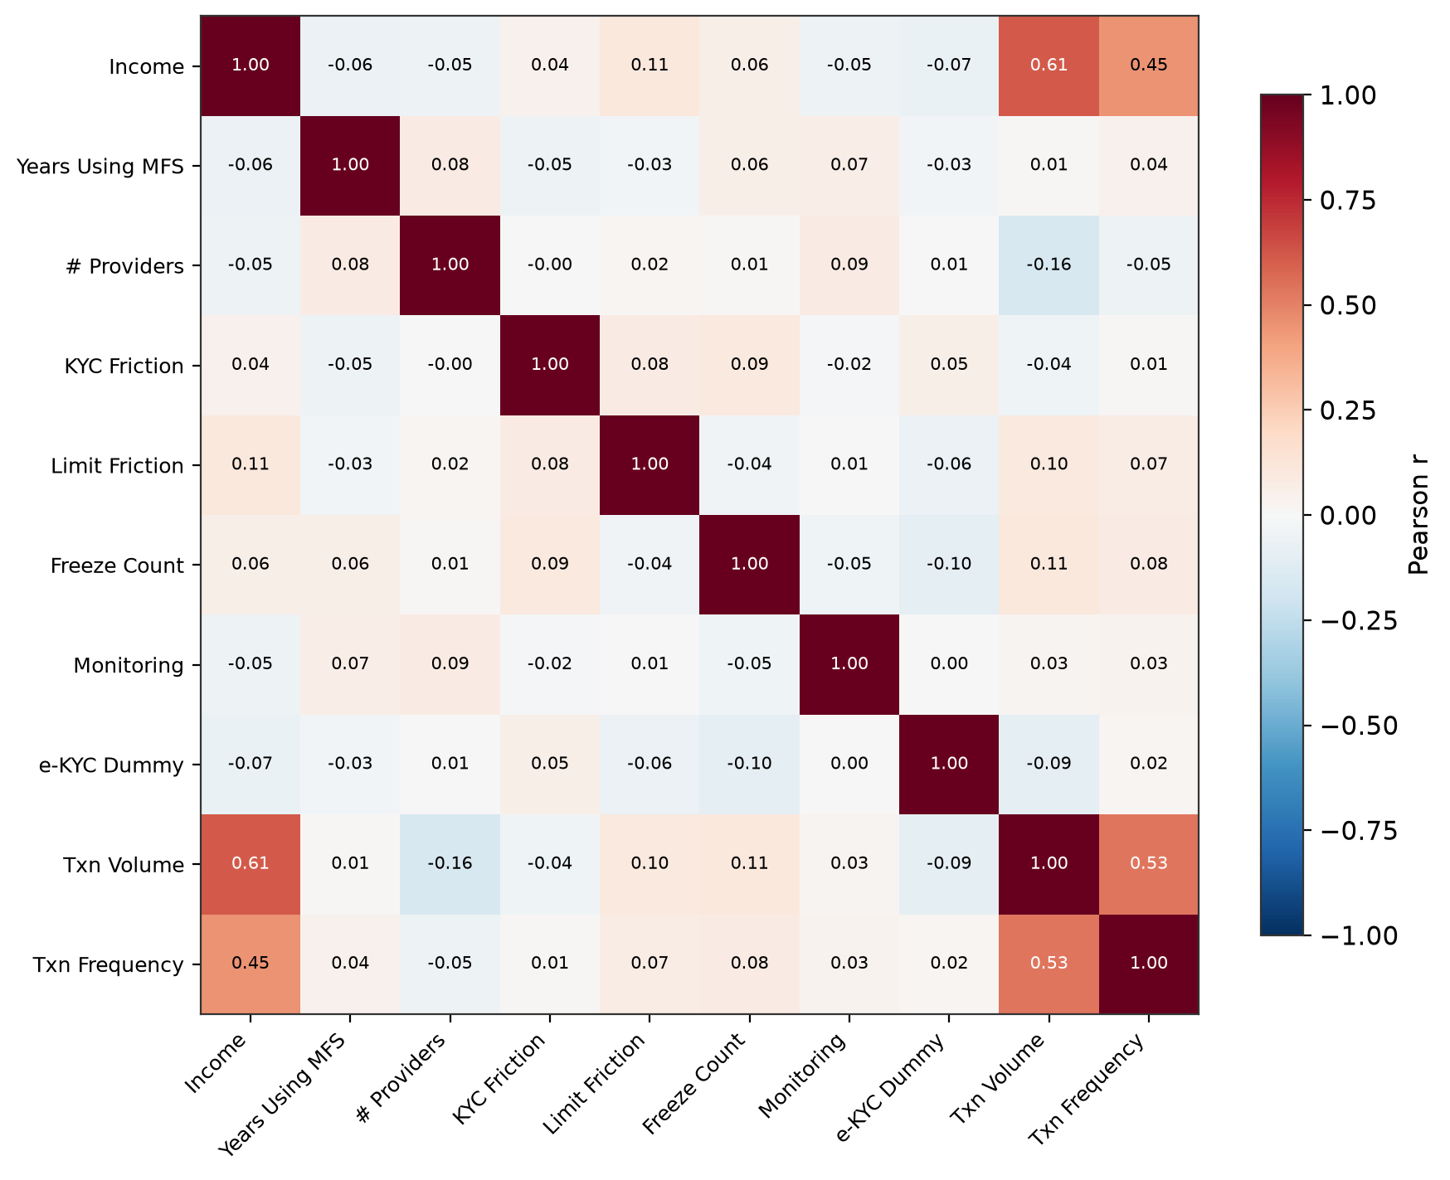
Figure 5: Pearson Correlation Matrix Heatmap

7.6 Primary Model: Ordinal Logistic Regression
The primary model regressed the six category transaction volume outcome on all ten predictors, using 246 respondents after the 10 Not sure e-KYC cases were excluded.
Table 12: Ordinal Logistic Model Summary
N | Categories | Log Lik. | McFadden's R² | LR χ² | df | p
246 | 6 | -336.59 | 0.2215 | 191.49 | 10 | < .001

The overall model is highly significant (LR χ² = 191.49, df = 10, p < .001). McFadden's R² of 0.22 is a respectable fit for this kind of model, though the significance is driven by only two of the ten predictors, as Table 10 shows.
Table 13: Ordinal Logistic Coefficients (DV: Transaction Volume Category)
Variable | B (logit) | SE | Odds Ratio | z | p | Sig.
KYC Friction | -0.092 | 0.127 | 0.912 | -0.727 | 0.4672
Limit Friction | 0.155 | 0.101 | 1.168 | 1.541 | 0.1233
Freeze Count | 0.227 | 0.163 | 1.255 | 1.390 | 0.1646
Monitoring Perception | 0.152 | 0.107 | 1.164 | 1.420 | 0.1557
e-KYC Dummy | 0.067 | 0.392 | 1.070 | 0.172 | 0.8635
Income (standardized) | 2.064 | 0.178 | 7.876 | 11.576 | < .001 | *
Age (standardized) | 0.055 | 0.167 | 1.057 | 0.330 | 0.7412
Years Using MFS (standardized) | 0.037 | 0.118 | 1.038 | 0.314 | 0.7532
Number of Providers | -0.432 | 0.102 | 0.649 | -4.245 | < .001 | *
Urban | 0.178 | 0.317 | 1.195 | 0.562 | 0.5743
* p < .05. Odds ratio below 1 for a friction variable supports the hypothesized direction.
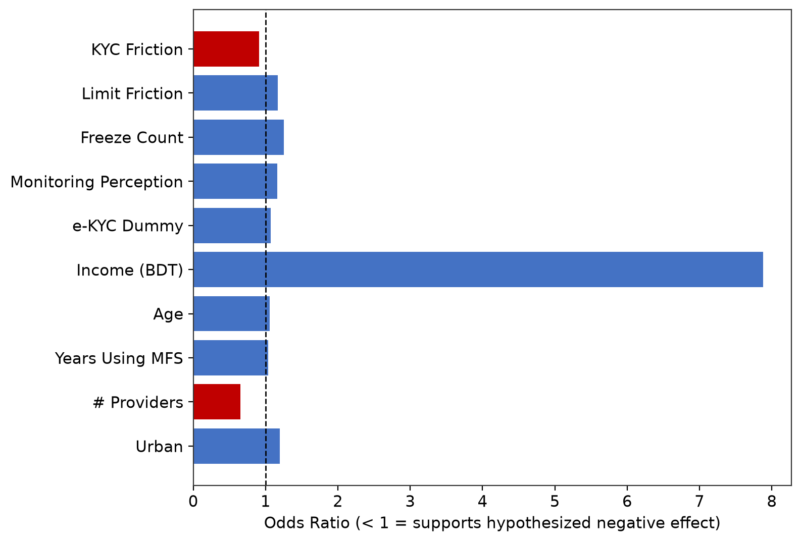
Figure 6: Odds Ratios from the Primary Model

7.6.1 Compliance Friction Variables
None of the four friction predictors, nor the KYC method comparison, reached significance. KYC friction (OR = 0.912, p = .467) points in the hypothesized direction but is not significant. Limit friction (OR = 1.168, p = .123), freeze count (OR = 1.255, p = .165), and monitoring (OR = 1.164, p = .156) point the opposite way, also not significant. The e-KYC dummy (OR = 1.070, p = .864) shows no meaningful difference between KYC methods.

7.6.2 Significant Predictors
Income was by far the strongest predictor (OR = 7.876 per SD, p < .001), confirming that respondents with more income simply move more money through MFS, unrelated to compliance. Number of providers was also significant, but in a counter intuitive direction: each additional provider used was associated with lower odds of higher volume (OR = 0.649, p < .001). Age, years of MFS use, and urban/rural residence were not significant.

7.7 Secondary Model: OLS Regression (Robustness Check)
The same predictors were run through OLS on the bracket midpoint version of transaction volume.

Table 14: OLS Model Summary (Robustness Check)
N | R² | Adj. R² | F | df1 | df2 | p
246 | 0.4459 | 0.4224 | 18.914 | 10 | 235 | < .001

The model explains 44.6% of the variance (Adj. R² = 0.422), and the overall model is highly significant (F = 18.914, p < .001).
Table 15: OLS Coefficients, HC3 Robust SE (DV: Transaction Volume, BDT)
Variable | B | SE Robust | t Robust | p Robust | Sig.
Constant | 3,429.49 | 7,215.28 | 0.475 | 0.6350
KYC Friction | -1,326.87 | 841.60 | -1.577 | 0.1162
Limit Friction | 852.07 | 749.34 | 1.137 | 0.2567
Freeze Count | 1,751.28 | 1,208.41 | 1.449 | 0.1486
Monitoring Perception | 1,854.81 | 1,041.97 | 1.780 | 0.0764
e-KYC Dummy | -1,659.28 | 2,349.55 | -0.706 | 0.4808
Income (BDT) | 0.392 | 0.036 | 10.885 | < .001 | *
Age | -36.91 | 99.27 | -0.372 | 0.7104
Years Using MFS | 369.76 | 557.54 | 0.663 | 0.5079
Number of Providers | -3,260.90 | 1,271.20 | -2.565 | 0.0109 | *
Urban | 1,543.31 | 1,938.36 | 0.796 | 0.4267
* p < .05, based on HC3 robust standard errors given the heteroskedasticity detected in Section 7.8.
The secondary model reaches the same conclusion: income (p < .001) and number of providers (p = .011) are the only significant predictors, and no compliance friction variable reaches significance. This convergence across two differently specified models shows the finding is not an artifact of how the outcome was measured.

7.8 Diagnostic Tests
Five diagnostic checks were run on the secondary OLS model.
Table 16: Variance Inflation Factors
Variable | VIF
KYC Friction | 1.05
Limit Friction | 1.03
Freeze Count | 1.04
Monitoring Perception | 1.02
e-KYC Dummy | 1.18
Income (BDT) | 1.03
Age | 1.19
Years Using MFS | 1.04
Number of Providers | 1.03
Urban | 1.04
All VIF values are well below the threshold of 5; multicollinearity is not a concern.
Table 17: Diagnostic Test Summary (Secondary OLS Model)
Test | Statistic | p | Verdict
Shapiro Wilk (normality) | 0.8413 | < .001 | Non normal
Jarque Bera (normality) | 312.3579 | < .001 | Non normal
Breusch Pagan (heteroskedasticity) | 19.2097 | 0.0377 | Heteroskedastic, addressed via HC3 SE
Durbin Watson (autocorrelation) | 2.064 | n/a | Not diagnostic for cross sectional data
Cook's Distance (influence) | 15 | n/a | 15 of 246 exceed 4/n threshold

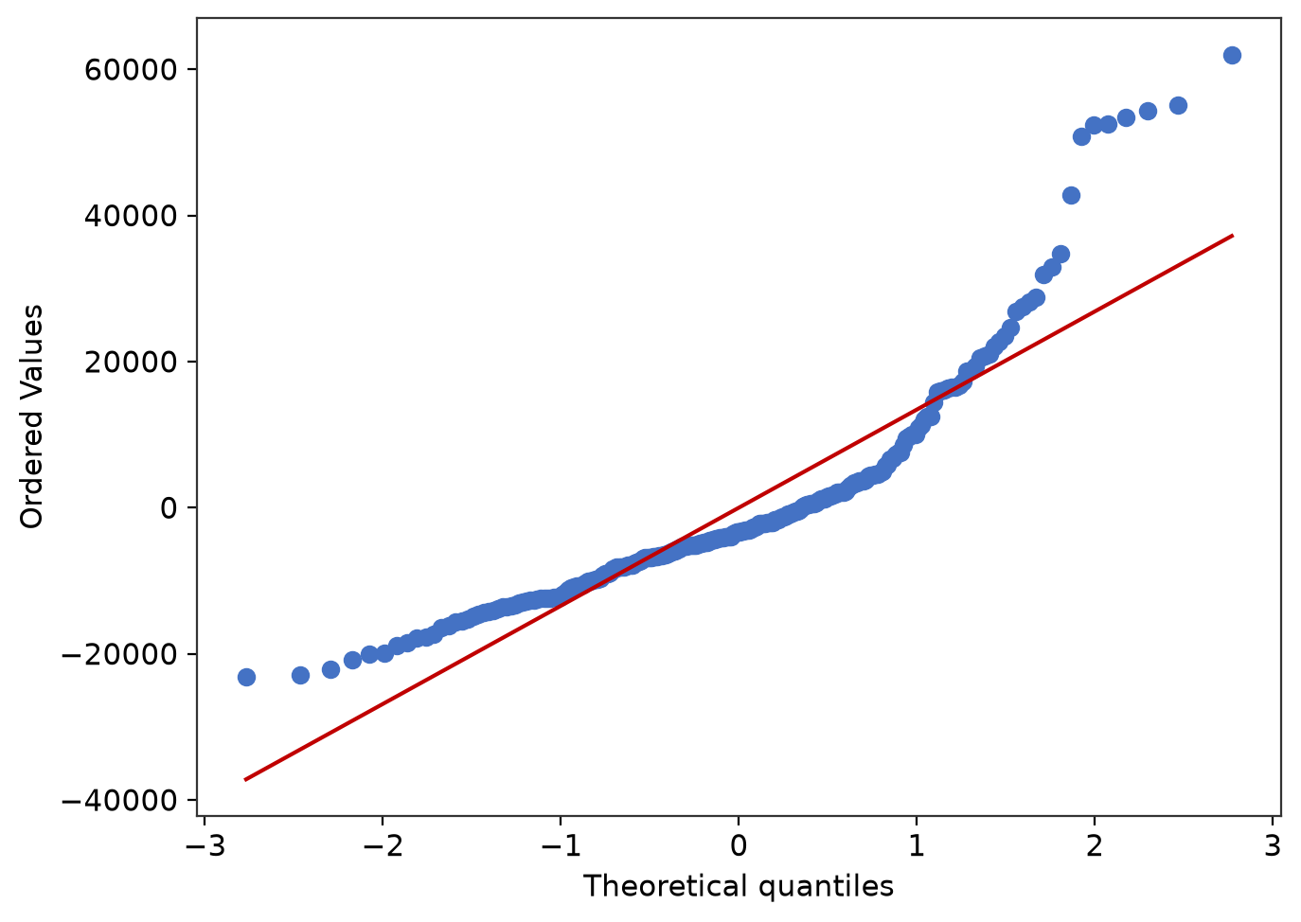

Figure 7: Normal Q-Q Plot of OLS Residuals
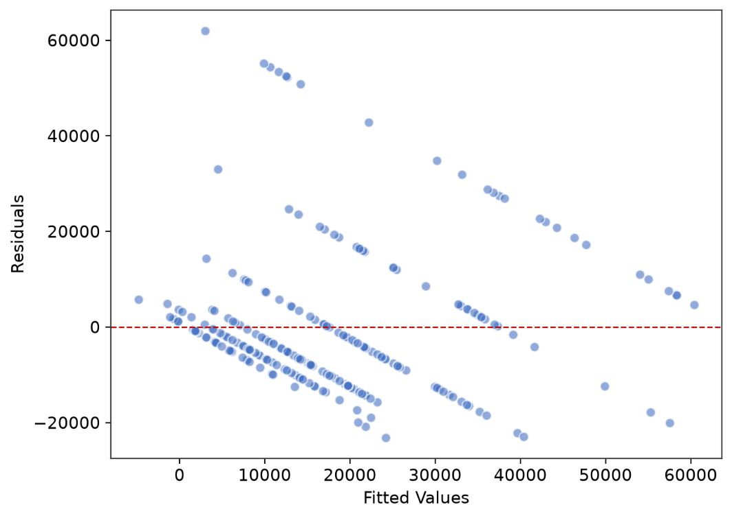
Figure 8: OLS Residuals versus Fitted Values

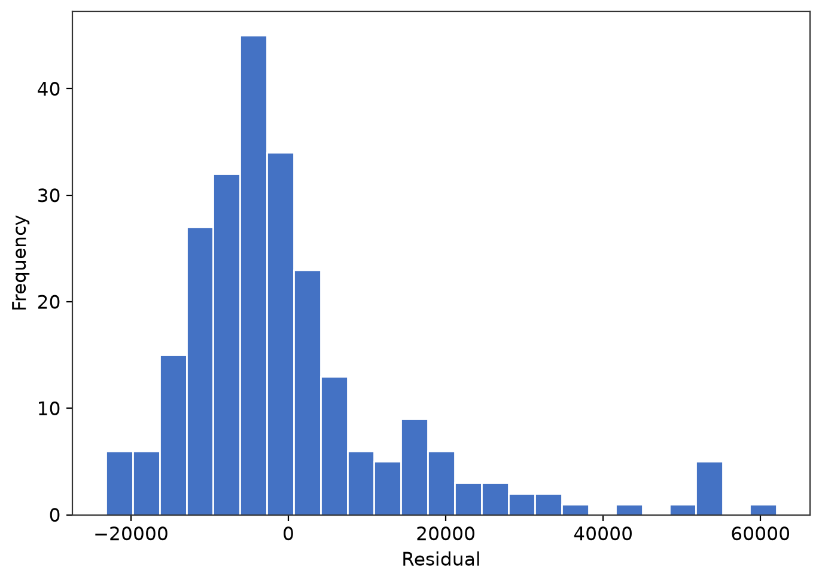
Figure 9: Residual Histogram
Residuals are non normal and heteroskedastic (both p < .001 and p = .038), visible in Figures and Tables above, expected since the outcome was built from bracket midpoints. This is why HC3 robust SE were used throughout, and why the ordinal model, which assumes nothing about residual shape, was designated primary. Durbin Watson (2.064) is near the no autocorrelation benchmark but is not meaningful for cross sectional data. Fifteen observations (6.1%) exceed the Cook's Distance threshold, a modest number of influential cases.

7.9 Hypothesis Testing Summary
A hypothesis is marked Supported only if its coefficient is both significant (p < .05) and points in the hypothesized negative direction.
Table 18: Hypothesis Testing Summary
Hypothesis | OR | p | Direction | Outcome
H1: KYC friction → lower usage | 0.912 | 0.4672 | As hypothesized | Not supported
H2: Limit friction → lower usage | 1.168 | 0.1233 | Opposite | Not supported
H3: Freezes → lower usage | 1.255 | 0.1646 | Opposite | Not supported
H4: Monitoring → lower usage | 1.164 | 0.1557 | Opposite | Not supported
H5: e-KYC vs. paper → different usage | 1.070 | 0.8635 | Opposite | Not supported

All five hypotheses are not supported. Within this sample of 246, once income and other factors are controlled, none of the four compliance friction dimensions, nor KYC method, showed a significant relationship with MFS usage.

7.10 Discussion: Why the Hypotheses Were Not Supported
A null result is still a real finding. Several non-exclusive reasons plausibly explain this pattern.
- Restricted range: the sample skews young, urban, and educated, the users least likely to experience severe friction, so there may be too little variation in lived friction to detect an effect that could exist in the wider population.
- Reverse causality: freeze count and monitoring came out positively, not negatively, associated with usage. This is consistent with risk based monitoring flagging accounts BECAUSE they transact more, not the other way round; a cross sectional survey cannot separate the two directions.
- Perception versus reality: the four friction items measure how friction felt, not the actual regulatory stringency applied, and this kind of measurement noise pulls correlations toward zero.
- Statistical power: standard errors on the friction coefficients (0.10 to 0.16) show only moderate precision; a smaller real effect could exist but fail to reach significance at N = 246.

7.11 Summary of Statistical Findings
Across two differently specified models, the same result holds: income and number of providers are the only significant predictors of MFS usage, and no measured dimension of AML/KYC compliance friction shows a significant relationship with usage once other factors are controlled. This is a genuine finding specific to this sample, method, and time, to be discussed in Chapter 8 with that scope stated clearly.

Chapter 8: Conclusion, Limitations and Recommendations

8.1 Summary of Findings
This study set out to test whether perceived AML/KYC compliance friction is associated with lower Mobile Financial Service (MFS) usage among Bangladeshi users, once income and other demographic and behavioral factors are controlled for. Using primary survey data from 256 respondents, cleaned to a final regression sample of 246, two independently specified statistical models were run: a primary ordinal logistic regression on the true six category transaction volume outcome, and a secondary OLS regression on a bracket midpoint approximation of the same outcome, reported with HC3 robust standard errors. Both models reached the same substantive conclusion.
Of the five hypotheses tested, none was supported. KYC friction pointed in the hypothesized direction but fell well short of significance (odds ratio = 0.912, p = .467). Limit friction, freeze count, and monitoring perception all pointed in the opposite direction from what was hypothesized, and none reached significance. The e-KYC dummy showed no meaningful difference between e-KYC and paper based KYC users. The two statistically significant predictors in both models were income (odds ratio = 7.876 per standard deviation, p < .001) and number of providers used (odds ratio = 0.649, p < .001), neither of which is a compliance variable.
Taken together, this sample does not provide evidence that AML/KYC compliance friction, as measured here, reduces MFS usage among Bangladeshi users once income and demographics are accounted for. Section 8.2 returns to the research question and objectives set out in Chapter 1 to state plainly what this finding does and does not mean. Section 8.5 sets out why this result should be read as specific to this sample and this method, not as a general verdict on the compliance and inclusion trade-off in Bangladesh.

8.2 Answering the Research Question and Objectives
Chapter 1 set out three specific objectives. The first was to measure the statistical association between compliance stringency indicators and MFS usage using multiple regression on primary survey data, controlling for demographic factors. This was done in full: the primary ordinal logistic model and the secondary OLS model both estimate this association directly, and both converge on the same answer. Within this sample, the association is not statistically significant for any of the four compliance dimensions measured, nor for KYC method.
The second objective was to identify which specific dimension of compliance friction, if any, shows the strongest association with reduced usage, rather than treating compliance as one undifferentiated burden. Keeping KYC friction, limit friction, freeze count, and monitoring perception as four separate predictors, rather than combining them into a single index, was the right methodological choice for this reason. It allowed the analysis to show that none of the four dimensions individually reached significance, and that where a direction could be observed at all, KYC friction was the only one pointing toward the hypothesized negative relationship. Freeze count and monitoring perception, if anything, moved in the opposite direction. This is itself informative: it suggests that if compliance friction has a meaningful effect on MFS usage in Bangladesh, this study was not able to isolate it through respondents' self reported experience of onboarding difficulty, transaction limits, freezes, or monitoring.
The third objective was to translate the findings into practical recommendations for bKash's compliance function and for Bangladesh Bank and BFIU. Sections 8.3 and 8.4 address this directly. Because the empirical result is a null finding rather than a confirmed negative relationship, the recommendations below are framed around what this result implies for how compliance friction should be monitored and interpreted going forward, rather than around a specific friction point that this study has shown to be costly in terms of lost usage.

8.3 Implications for bKash's Compliance Function
The internship placement within bKash's AML & CFT Governance team, described in Chapters 3 and 4, gives this study's null finding a practical grounding that a purely academic survey would not have. Three implications follow from combining the statistical result with that internship exposure.
First, the finding that freeze count and monitoring perception moved in the opposite direction from what was hypothesized is consistent with how a risk based transaction monitoring system is designed to work: accounts are more likely to be flagged, reviewed, or temporarily frozen because they transact more or transact unusually, not because the provider is arbitrarily restricting low value or low risk activity. If freezes and monitoring are being triggered primarily by usage intensity rather than applied indiscriminately, then the Governance team's existing risk based approach is functioning broadly as intended from a financial inclusion perspective, at least within the bounds of what this sample can show.
Second, the null result on the e-KYC dummy suggests that the shift from paper based to electronic KYC, which the Governance team and the wider AML & CFT Department have been supporting, has not measurably reduced or increased usage among the users surveyed here. This is a reassuring rather than a concerning finding for bKash: it indicates that tightening identity verification through e-KYC does not appear to be costing the company usage among this sample, even though the literature reviewed in Chapter 5 documents real difficulties with e-KYC adoption among rural and less digitally literate users nationally. The gap between this sample, which skews young, urban, and educated, and the population most likely to struggle with e-KYC is the most plausible explanation for why this study did not detect the barrier effect that Transparency International Bangladesh's 2025 study and the BFIU and AFI study paper both describe at a policy level.
Third, the governance monitoring tool project described in Section 3.7 has an indirect but genuine connection to this finding. A department that can track KYC method, freeze frequency, and monitoring flags more reliably, through better internal data infrastructure, is better placed to eventually test a finding like this one against actual transaction records rather than self reported survey responses. The recommendation that follows directly from this is that bKash's compliance function would benefit from occasionally validating perception based findings such as this one against its own internal, anonymized usage data, since internal data would not be subject to the same self selection and self report limitations discussed in Section 8.5.

8.4 Implications for Regulators
For Bangladesh Bank and BFIU, this study's central contribution is methodological rather than a call to loosen or tighten any specific requirement. The BFIU and Alliance for Financial Inclusion study paper reviewed in Chapter 5 proposed a Progressive KYC model on the reasonable assumption that uniform, maximal documentation requirements impose a real usage cost on lower risk, lower value accounts. This study looked for that cost directly, at the level of individual users, and did not find statistically significant evidence of it in this particular sample.
This does not mean the concern behind Progressive KYC is wrong. It means that if a usage cost from compliance friction exists in the broader Bangladeshi MFS user population, this study's convenience sample of comparatively young, urban, and educated respondents was not well positioned to detect it, for the reasons discussed in Section 8.5.1. The practical implication for regulators is that any future evaluation of a tiered or risk based KYC proposal should prioritize reaching rural, older, and less digitally literate MFS users directly, since this is precisely the population in which a real friction effect, if one exists, would be most visible and most policy relevant. A survey reached primarily through university networks, a public Facebook profile, and online forums, as this one was, is structurally unlikely to capture that population in sufficient numbers.
A second, narrower implication concerns e-KYC specifically. Since this study found no significant usage difference between e-KYC and paper based KYC users, and the literature in Chapter 5 documents adoption difficulties with e-KYC among rural users, the more useful question for regulators may not be whether e-KYC reduces usage among people who have already adopted it, which this study suggests it does not, but whether e-KYC access itself is unevenly distributed before adoption ever happens. That distinction, between friction experienced by existing users and friction that prevents someone from becoming a user in the first place, was outside the scope of this study's screening design, since only current MFS users were eligible to respond.

8.5 Limitations of the Study
The limitations below extend the ones already noted in Section 1.7 and Section 7.10, drawing them together in one place now that the full results are in hand.

8.5.1 Sample Composition
The sample was reached through university and batch group chats, a public Facebook profile, and online forums including TorrentBD, over a one week collection window. As Table 7.5a through 7.5d in Chapter 7 show, two thirds of respondents were 18 to 34 years old, over half held a Bachelor's degree, and two in three lived in urban areas. This is precisely the segment of MFS users least likely to experience the compliance friction that Chapter 5's literature review identifies as a barrier for rural, older, and less digitally literate users nationally. A null finding in a sample skewed this way should not be read as evidence that compliance friction has no cost for the wider MFS user population, only that this particular sample did not contain enough of the users most exposed to that cost to detect it statistically.

8.5.2 Cross Sectional Design and Reverse Causality
The survey captured each respondent at a single point in time. This means the analysis can establish association, not causation, and it cannot rule out that the direction of causality runs opposite to what was hypothesized for some variables. The positive, though not significant, coefficients on freeze count and monitoring perception are the clearest example: an account that transacts more may be more likely to be flagged or monitored as a consequence of that usage, rather than usage being suppressed by the monitoring itself. Distinguishing these two directions would require either longitudinal data, tracking the same users' usage before and after a freeze or monitoring event, or access to provider side transaction records, neither of which was available for a student conducted internship report of this scope.

8.5.3 Self Reported and Perception Based Measures
All four compliance variables measure how friction felt to the respondent on a Likert scale, not the actual regulatory stringency applied to their account, and transaction volume and frequency were also self reported rather than drawn from verified records. Measurement error of this kind tends to pull correlations toward zero, meaning a real underlying relationship could exist and still fail to appear significant in data collected this way.

8.5.4 Sample Size and Statistical Power
A final regression sample of 246 gave more than enough power to detect the strong, well established relationship between income and usage, but the standard errors on the compliance friction coefficients, roughly 0.10 to 0.16 in the ordinal model, indicate the study could reliably detect only a moderately large effect. A smaller, genuinely policy relevant effect could exist in the population and still not be distinguishable from zero at this sample size. This is a different conclusion from saying compliance friction has no effect, and the distinction matters for how this finding should be used going forward.

8.5.5 Scope of the Organizational Component
The organizational description in Chapters 2 through 4 is based on a thirteen week placement within one team, Governance, inside bKash's ten team AML & CFT Department. It reflects what was directly observed and learned from working knowledge shared by colleagues, not a comprehensive audit of the department's practices, and it should not be generalized to other MFS providers in Bangladesh.

8.6 Suggestions for Future Research
Three directions follow naturally from the limitations above.
Targeted sampling of rural and older MFS users, ideally through agent networks or field based data collection rather than digital distribution alone, to test whether the null finding reported here holds in the population segment most likely to experience real compliance friction.
Longitudinal or provider linked data that can observe the same users' usage before and after a freeze, monitoring flag, or KYC method change, to separate the direction of causality that a cross sectional survey cannot.
Validation against internal, anonymized provider data, comparing self reported usage and compliance experience against actual transaction records for the same accounts, which would remove the self report and perception based measurement limitations discussed in Section 8.5.3.

8.7 Concluding Remarks
This study asked a specific, testable question: does perceived AML/KYC compliance friction reduce MFS usage among Bangladeshi users once income and demographics are controlled for. Within a sample of 246 respondents, reached primarily through digital and university networks, the answer this data supports is no, not at a level that reaches statistical significance, across two independently specified models. Income and the number of MFS providers used were the only variables that mattered in this sample.
The most plausible reading, developed across Sections 7.10 and 8.5, is that this study's convenience sample was structurally better positioned to detect the strong, well known relationship between income and usage than the more subtle, unevenly distributed effect of compliance friction that existing literature suggests falls hardest on exactly the users this sample under-represents. Read this way, the study's contribution is not a settled answer to the compliance and financial inclusion trade-off in Bangladesh, but a clear demonstration of where the next attempt to answer it should look: toward the rural, older, and less digitally literate users this sample did not reach in sufficient numbers, and toward data that can separate cause from effect in a way a single cross sectional survey cannot.

References
Al-Mahdi, A. (2025). An insight into bKash’s Anti Money Laundering (AML) & Combating the Financing of Terrorism (CFT) practices to ensure perceived security and to inspire customer trust [Unpublished undergraduate thesis]. United International University. http://dspace.uiu.ac.bd/handle/52243/3200
Bangladesh Bank. (2017). AML/CFT regulations for mobile money: Global standards & practices, risk & trend, and policy options for Bangladesh. https://www.bb.org.bd/pub/research/sp_research_work/srw1704old.pdf
Bangladesh Bank. (2022). Bangladesh Mobile Financial Services (MFS) Regulations, 2022. https://www.bb.org.bd/mediaroom/circulars/psd/feb152022psd04e.pdf
Bangladesh Bank. (2025). Bangladesh Payment Systems Report, 2025. https://www.bb.org.bd/pub/annual/psdreport/paymentreport_dec2025.pdf
Bangladesh Bank. (2026, March 11). Guidelines on Electronic Know-Your-Customer (e-KYC) (Circular No. BRPD-108). https://www.bb.org.bd/mediaroom/circulars/brpd/mar112026brpd-108e.pdf
Bangladesh Financial Intelligence Unit. (2020). Guidelines on Electronic Know Your Customer (e-KYC) (Circular No. 25). https://bfiu.org.bd/pdf/circular/aml/jan082020bfiu25.pdf
Bangladesh Financial Intelligence Unit & Alliance for Financial Inclusion. (2017). AML/CFT regulations for mobile money: Policy options for Bangladesh. https://www.bb.org.bd/pub/research/sp_research_work/srw1704old.pdf
bdnews24. (2025, March 23). Bangladesh MFS accounts surge by 20 million in a year, transactions up 32pc. https://bdnews24.com/business/643d8765ba8a
Bonikbarta. (2026, June 7). How bKash became a BDT 160 billion enterprise from a startup. https://en.bonikbarta.com/business/dt2VlJjSIXS99Mic
Carnegie Endowment for International Peace. (2023, July 13). The limits of accelerating digital-only financial inclusion. https://carnegieendowment.org/research/2023/07/the-limits-of-accelerating-digital-only-financial-inclusion
Financial Action Task Force. (2012). International standards on combating money laundering and the financing of terrorism & proliferation. https://www.fatf-gafi.org/en/publications/
Financial Action Task Force. (2025). Guidance on financial inclusion and anti-money laundering and terrorist financing measures. https://www.fatf-gafi.org/en/publications/Financialinclusionandnpoissues/guidance-financial-inclusion-aml-tf-measures.html
Future Startup. (2025, April 22). A brief history of bKash: Trajectory, funding, and lessons. https://futurestartup.com/2025/04/22/a-brief-history-of-bkash-trajectory-funding-and-lessons/
Gelb, A., & Castrillon, D. (2019). Identifying and verifying customers: When are KYC requirements likely to become constraints on financial inclusion? (Working Paper 522). Center for Global Development. https://www.cgdev.org/sites/default/files/identifying-and-verifying-customers-when-are-kyc-requirements-likely-become-constraints.pdf
GSMA. (2019). Innovative solutions to Know Your Customer (KYC) regulations in emerging markets. https://www.gsma.com/solutions-and-impact/connectivity-for-good/mobile-for-development/programme/digital-identity/innovative-solutions-to-know-your-customer-kyc-regulations-in-emerging-markets/
GSMA. (2026). The state of the industry report on mobile money 2026. https://www.gsma.com/sotir/
Natile, S. (2016). Mobile money and the limits of financial inclusion: A gender analysis of M-Pesa in Kenya [Doctoral thesis, University of Kent]. https://kar.kent.ac.uk/60909/
Parvez, J., Islam, A., & Woodard, J. (2015). Mobile Financial Services in Bangladesh: A survey of current services, regulations, and usage in select USAID projects. mSTAR/USAID. https://www.findevgateway.org/paper/2015/04/mobile-financial-services-bangladesh-survey-current-services-regulations-and-usage
Rahman, H., & bin Ahsan, W. (2024). Fraud mitigation, usability challenges, and financial literacy in mobile financial services for rural Bangladesh. UserHub Journal. https://doi.org/10.58947/journal.wpgr45
RocketReach. (n.d.). bKash Limited management team. Retrieved August 16, 2026, from https://rocketreach.co/bkash-limited-management_b5e46067f42e6559
The Bangladesh Express. (2025, August 27). Nagad to be fully privatised to increase competition in MFS: BB Governor. https://www.thebangladeshexpress.com/business/18198
The Daily Star. (2026, August 8). From SIM to MFS: Govt tightening digital crime net. https://tob.news/from-sim-to-mfs-govt-tightening-digital-crime-net/
The Financial Express. (2022, June 22). AML & CFT compliance: Building block of MFS industry. https://thefinancialexpress.com.bd/print/aml-cft-compliance-building-block-of-mfs-industry-1655305255
The Financial Express. (2022, November 30). Competition landscape of the MFS industry in Bangladesh. https://thefinancialexpress.com.bd/views/views/competition-landscape-of-the-mfs-industry-in-bangladesh-1669733150
Transparency International Bangladesh. (2025). Governance challenges in mobile financial services sector in Bangladesh: Extended executive summary. https://www.ti-bangladesh.org/images/2025/report/mfs/Executive-Summary-Mobile-Financial-Services-Sector-En.pdf
UserHub. (2025). Fraud mitigation, usability challenges, and financial literacy in Mobile Financial Services in rural Bangladesh. https://userhub.com.bd/download/report/fraud-mitigation-usability-challenges-financial-literacy-mobile-financial-services-rural-bangladesh.pdf
World Journal of Advanced Engineering Technology and Sciences. (2025). The impact of mobile financial services in Bangladesh: Usage patterns and challenges. World Journal of Advanced Engineering Technology and Sciences, 16, 1290–1305. https://wjaets.com/sites/default/files/fulltext_pdf/WJAETS-2025-1290.pdf

Appendices
Appendix A: Survey Questionnaire (Google Form)
The instrument below is reproduced exactly as it appeared in the live Google Form used for data collection, bilingual in English and Bangla, comprising nineteen questions across four sections. The form was live from 9 August 2026 to 15 August 2026.
Form Description (shown to every respondent before Section 0)
"This survey is part of an academic thesis research on Mobile Financial Services (bKash, Nagad, Rocket, etc.) in Bangladesh. Your responses are completely anonymous and will only be used for academic purposes. It will take less than 5 minutes."
"এই জরিপটি বাংলাদেশে মোবাইল ফাইন্যান্সিয়াল সার্ভিস (বিকাশ, নগদ, রকেট ইত্যাদি) নিয়ে একাডেমিক গবেষণার অংশ। আপনার তথ্য সম্পূর্ণ গোপন রাখা হবে এবং শুধুমাত্র গবেষণার কাজে ব্যবহার করা হবে। এটি পূরণ করতে ৫ মিনিটের কম সময় লাগবে।"
Section 0: Consent and Screening / সম্মতি ও স্ক্রিনিং
Q0.1. Do you currently use any Mobile Financial Service (bKash, Nagad, Rocket, Upay, etc.)?
আপনি কি বর্তমানে কোনো মোবাইল ফাইন্যান্সিয়াল সার্ভিস (বিকাশ, নগদ, রকেট, উপায় ইত্যাদি) ব্যবহার করেন?
- Yes / হ্যাঁ
- No / না (if No, form ends here)
Q0.2. Are you 18 years or older?
আপনার বয়স কি ১৮ বছর বা তার বেশি?
- Yes / হ্যাঁ
- No / না (if No, form ends here)

Section 1: Demographics and Control Variables / জনতাত্ত্বিক তথ্য
Q1.1. Age / বয়স
- 18 to 24
- 25 to 34
- 35 to 44
- 45 to 54
- 55 or above / ৫৫ বা তার বেশি
Q1.2. Gender / লিঙ্গ
- Male / পুরুষ
- Female / নারী
- Prefer not to say / বলতে ইচ্ছুক নই
Q1.3. Highest Education Level / সর্বোচ্চ শিক্ষাগত যোগ্যতা
- SSC or below / এসএসসি বা তার নিচে
- HSC / এইচএসসি
- Bachelor's / স্নাতক
- Master's or above / স্নাতকোত্তর বা তার বেশি
Q1.4. Area of Residence / বসবাসের এলাকা
- Urban / শহর
- Rural / গ্রাম
Q1.5. Monthly Personal Income (BDT) / মাসিক ব্যক্তিগত আয় (টাকা)
- No income / কোনো আয় নেই
- Below 15,000
- 15,000 to 30,000
- 30,001 to 50,000
- 50,001 to 100,000
- Above 100,000
Q1.6. How long have you been using MFS? আপনি কতদিন ধরে MFS ব্যবহার করছেন?
- Less than 1 year / ১ বছরের কম
- 1 to 3 years / ১-৩ বছর
- 3 to 5 years / ৩-৫ বছর
- More than 5 years / ৫ বছরের বেশি
Q1.7. How many MFS providers do you actively use (bKash, Nagad, Rocket, Upay, etc.)? আপনি কতটি MFS প্রোভাইডার নিয়মিত ব্যবহার করেন?
- 1
- 2
- 3 or more / ৩ বা তার বেশি

Section 2: Financial Inclusion / Usage (Dependent Variable) / আর্থিক ব্যবহার
Q2.1. Approximately how much money do you transact (send + receive + pay + cash out, total) through MFS per month? প্রতি মাসে আপনি MFS-এর মাধ্যমে আনুমানিক কত টাকা লেনদেন (পাঠানো+গ্রহণ+পেমেন্ট+ক্যাশ আউট মিলিয়ে) করেন?
- Below 2,000 Taka
- 2,000 to 5,000 Taka
- 5,001 to 10,000 Taka
- 10,001 to 25,000 Taka
- 25,001 to 50,000 Taka
- Above 50,000 Taka
Q2.2. How many transactions (cash in/out, send money, payment, mobile recharge, etc.) do you make on MFS in a typical month? একটি সাধারণ মাসে আপনি MFS-এ কতগুলো লেনদেন করেন?
- 1 to 5
- 6 to 10
- 11 to 20
- More than 20 / ২০ এর বেশি
Q2.3. Which services do you use on MFS? (Select all that apply) আপনি MFS-এ কোন সেবাগুলো ব্যবহার করেন?
- Cash In/Out / ক্যাশ ইন/আউট
- Send Money / সেন্ড মানি
- Bill Payment / বিল পেমেন্ট
- Mobile Recharge / মোবাইল রিচার্জ
- Merchant/Shop Payment / মার্চেন্ট পেমেন্ট
- Savings/DPS / সঞ্চয়
- Others / অন্যান্য

Section 3: KYC and Compliance Experience (Independent Variables) / কেওয়াইসি ও কমপ্লায়েন্স অভিজ্ঞতা
Q3.1. How did you complete your MFS account KYC (identity verification)? আপনি কীভাবে আপনার MFS একাউন্টের কেওয়াইসি সম্পন্ন করেছিলেন?
- Paper based (visited agent with documents) / কাগজপত্র দিয়ে (এজেন্টের কাছে গিয়ে)
- e-KYC (app/online, selfie + NID scan) / ই-কেওয়াইসি (অ্যাপে/অনলাইনে)
- Not sure / নিশ্চিত না
Q3.2. How easy or difficult was the KYC/account opening process? কেওয়াইসি/একাউন্ট খোলার প্রক্রিয়াটি কতটা সহজ বা কঠিন ছিল?
Section 2: Financial Inclusion / Usage (Dependent Variable) / আর্থিক ব্যবহার
Q2.1. Approximately how much money do you transact (send + receive + pay + cash out, total) through MFS per month? প্রতি মাসে আপনি MFS-এর মাধ্যমে আনুমানিক কত টাকা লেনদেন (পাঠানো+গ্রহণ+পেমেন্ট+ক্যাশ আউট মিলিয়ে) করেন?
- Below 2,000 Taka
- 2,000 to 5,000 Taka
- 5,001 to 10,000 Taka
- 10,001 to 25,000 Taka
- 25,001 to 50,000 Taka
- Above 50,000 Taka
Q2.2. How many transactions (cash in/out, send money, payment, mobile recharge, etc.) do you make on MFS in a typical month? একটি সাধারণ মাসে আপনি MFS-এ কতগুলো লেনদেন করেন?
- 1 to 5
- 6 to 10
- 11 to 20
- More than 20 / ২০ এর বেশি
Q2.3. Which services do you use on MFS? (Select all that apply) আপনি MFS-এ কোন সেবাগুলো ব্যবহার করেন?
- Cash In/Out / ক্যাশ ইন/আউট
- Send Money / সেন্ড মানি
- Bill Payment / বিল পেমেন্ট
- Mobile Recharge / মোবাইল রিচার্জ
- Merchant/Shop Payment / মার্চেন্ট পেমেন্ট
- Savings/DPS / সঞ্চয়
- Others / অন্যান্য

Section 3: KYC and Compliance Experience (Independent Variables) / কেওয়াইসি ও কমপ্লায়েন্স অভিজ্ঞতা
Q3.1. How did you complete your MFS account KYC (identity verification)? আপনি কীভাবে আপনার MFS একাউন্টের কেওয়াইসি সম্পন্ন করেছিলেন?
- Paper based (visited agent with documents) / কাগজপত্র দিয়ে (এজেন্টের কাছে গিয়ে)
- e-KYC (app/online, selfie + NID scan) / ই-কেওয়াইসি (অ্যাপে/অনলাইনে)
- Not sure / নিশ্চিত না
Q3.2. How easy or difficult was the KYC/account opening process? কেওয়াইসি/একাউন্ট খোলার প্রক্রিয়াটি কতটা সহজ বা কঠিন ছিল?
Scale: 1 = Very Difficult / খুবই কঠিন, to 5 = Very Easy / খুবই সহজ
Q3.3. How often do you feel your transactions are restricted by transaction limits (daily/monthly cap)? আপনি কতবার মনে করেন যে আপনার লেনদেন সীমা দ্বারা সীমাবদ্ধ হয়?
Scale: 1 = Very Frequently / খুব ঘন ঘন, to 5 = Never / কখনোই না
Q3.4. Has your MFS account ever been temporarily frozen/blocked or flagged for verification? আপনার MFS একাউন্ট কি কখনো সাময়িকভাবে ব্লক/ফ্রিজ বা ভেরিফিকেশনের জন্য চিহ্নিত হয়েছে?
- Never / কখনো না
- Once / একবার
- 2 to 3 times / ২-৩ বার
- More than 3 times / ৩ বারের বেশি
Q3.5. How much do you feel your MFS activity is monitored (by the provider) for security purposes? নিরাপত্তার স্বার্থে আপনার MFS কার্যক্রম প্রোভাইডার কর্তৃক কতটা পর্যবেক্ষণ করা হয় বলে আপনি মনে করেন?
Scale: 1 = Not at all / একদমই না, to 5 = Very Heavily / অনেক বেশি
Q3.6. Overall, how satisfied are you with the balance between security checks and ease of use on MFS? সার্বিকভাবে, MFS-এ নিরাপত্তা যাচাই ও ব্যবহারের সহজতার মধ্যে ভারসাম্য নিয়ে আপনি কতটা সন্তুষ্ট?
Scale: 1 = Very Dissatisfied / খুবই অসন্তুষ্ট, to 5 = Very Satisfied / খুবই সন্তুষ্ট
End of Survey / জরিপ শেষ
"Thank you for your time! Your response has been recorded."
"আপনার সময়ের জন্য ধন্যবাদ! আপনার উত্তর রেকর্ড করা হয়েছে।"
Appendix B: Variable Coding Reference
The table below restates the coding scheme applied to the raw Google Form export during cleaning, referenced in Section 6.4 and implemented in 01_clean.py. This is provided separately as a quick coding lookup for anyone auditing the dataset against the raw form responses.
Table B.1: Raw Response to Coded Value Mapping
Question | Response Options (as they appear in the form) | Coded Value
Q1.5, income | No income / Below 15,000 / 15,000 to 30,000 / 30,001 to 50,000 / 50,001 to 100,000 / Above 100,000 | 0 / 7,500 / 22,500 / 40,000 / 75,000 / 125,000
Q1.6, MFS tenure | Less than 1 year / 1 to 3 years / 3 to 5 years / More than 5 years | 0.5 / 2 / 4 / 6
Q1.7, providers used | 1 / 2 / 3 or more | 1 / 2 / 3
Q2.1, transaction volume | Below 2,000 / 2,000 to 5,000 / 5,001 to 10,000 / 10,001 to 25,000 / 25,001 to 50,000 / Above 50,000 | Category 1 to 6 (ordinal); midpoint 1,000 / 3,500 / 7,500 / 17,500 / 37,500 / 65,000 for the secondary model
Q2.2, transaction frequency | 1 to 5 / 6 to 10 / 11 to 20 / More than 20 | Midpoint 3 / 8 / 15 / 25
Q3.1, KYC method | Paper based / e-KYC / Not sure | 0 / 1 / missing
Q3.2, KYC ease | Likert 1 (Very Difficult) to 5 (Very Easy) | Reverse coded: kyc_friction = 6 minus raw score
Q3.3, limit restriction | Likert 1 (Very Frequently) to 5 (Never) | Reverse coded: limit_friction = 6 minus raw score
Q3.4, freeze history | Never / Once / 2 to 3 times / More than 3 times | 0 / 1 / 2 / 3
Q3.5, monitoring perception | Likert 1 (Not at all) to 5 (Very Heavily) | Used as recorded, 1 to 5
Q3.6, satisfaction | Likert 1 (Very Dissatisfied) to 5 (Very Satisfied) | Used as recorded, 1 to 5

Appendix C: Scripts and Data Availability
The full analysis pipeline used to produce the tables and figures in Chapter 7 is hosted publicly on GitHub. The three scripts run in sequence, each taking the previous script's output as its input.
Table C.1: Analysis Scripts
Script | Function
01_clean.py | Reads the raw Google Form export, applies eligibility filtering, converts every response into its coded form, reverse codes the friction items, flags data quality issues, and writes coded_dataset.xlsx.
02_analysis.py | Reads coded_dataset.xlsx and runs descriptive statistics, reliability analysis, correlation analysis, the primary ordinal logistic regression, the secondary OLS regression with HC3 robust standard errors, all diagnostic tests, and the hypothesis testing summary. Exports every table to analysis_tables.xlsx.
03_chart.py | Reads coded_dataset.xlsx and produces all six figures referenced in Chapter 7.

Scripts referenced above are hosted publicly:
https://github.com/zaifears/thesis/blob/main/01_clean.py
https://github.com/zaifears/thesis/blob/main/02_analysis.py
https://github.com/zaifears/thesis/blob/main/03_chart.py
https://github.com/zaifears/thesis.git

